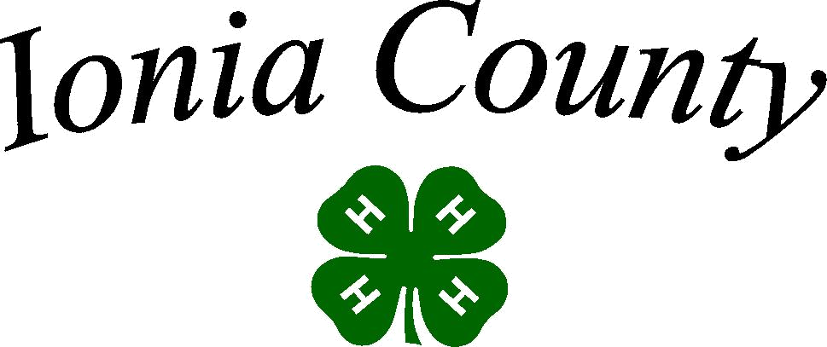

Dairy Project
Record Book
Intermediate (Age 12-14)

Do NOT put this record book in a binder.

Michigan State University Extension programs and materials are open to all without regard to race, color, national origin, gender, religion, age, disability, political beliefs, sexual orientation, marital or family status.


Name:

4-H Club:

4-H Leader:

Age (as of 1/1):__________________ Years in 4-H Dairy Project:

Rev.

4/2014

Why Keep Records?
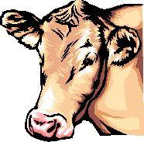

Members learn more about their project animals - costs, feed, health and management skills.

Documents activities and progress in the project.

Improves management and production

practices. Helps plan future projects.

Keep this record as part of your Personal 4-H Records.

This information is helpful in applying for 4-H awards and scholarships.
Remember - records are no better than what YOU put into them!

Leader’s Comments:

Dairy Leader’s Signature:

Extra Credit for my Dairy Project?

An outstanding 4-H project record is one that goes above and beyond what is expected. Be creative!

- A completed record book should have a beginning and final photograph. You are encouraged to be in the photo with your project animal(s) and to include more photographs. Include captions. You may use additional pages.

- Write a report on a related topic of at least one page:

Proper Care and Nutrition; Selection; Animal Science; Safe Management Practices or Diagram of Farm Set-up; Veterinary Science; Food Products (such as sample “healthy” recipes) of cheese or milk, etc.

Ionia County MSU Extension
50 E. Sprague Rd.
Ionia, MI 48846
Phone: (616) 527—5357
Fax: (616) 522—1449

2
Dairy Project Summary

Number of years in the Dairy Project, including this year? __________

Number of project meetings held: _______________ Number I attended:

I gave ________________ project talks or demonstrations.

Topics were:

_________________________________________________________________________________________

_________________________________________________________________________________________

_________________________________________________________________________________________

Have you participated in other dairy activities? Yes_____ No_____

If yes, list the activities, shows, fairs or related programs attended: What were the three most important things you learned this year about dairy?

_________________________________________________________________________________________

_________________________________________________________________________________________

_________________________________________________________________________________________

What were the three most important things you learned this year about dairy?

_________________________________________________________________________________________

_________________________________________________________________________________________

_________________________________________________________________________________________

What are your goals for this year’s dairy project?

_________________________________________________________________________________________

_________________________________________________________________________________________

_________________________________________________________________________________________

3

Dairy Project Photos

Be creative. The more photos, the better! You are encouraged to be in the photo with your Dairy project animal(s). You should also include captions on your pictures that at least include the date of the photograph.

4

Name the Parts

All ages

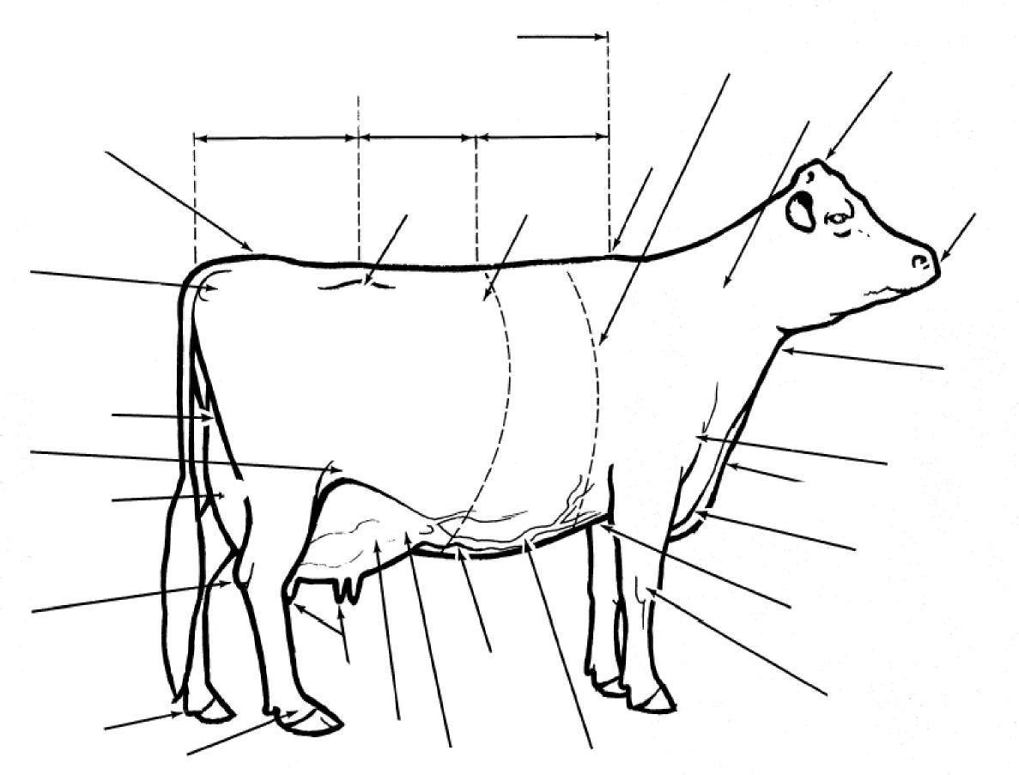
Write the number from the word bank to label the parts.

17. Neck
18. Chine
19. Teats
20. Point of Shoulder
21. Foreudder
22. Foreudder attachment
23. Tail Head
24. Loin
25. Milk Wells
26. Hock
27. Chest floor
28. Pastern
29. Barrel
30. Withers

- Muzzle
- Hip
- Dewclaw
- Brisket
- Throat
- Dewlap
- Knee
- Flank
- Pin Bones
- Heart Girth
- Back
- Rump
- Mammary Veins
- Poll
- Rear udder
- Rear udder attachment

Management Records

Fill out one of these pages per dairy project (you may have leftover pages).

Name: | Breed: | Control or ID Number:

Date of Birth or Age:

RFID (required):


Tattoo: Left -

Right -

How often do you feed/water your project?

What does your animal’s feed consist of?

What type of bedding do you use for your dairy project?

Do you milk your own dairy project? If so, how often? If someone else milks your dairy project, how often do they do so?

If your dairy project is milked, what is the milking procedure from beginning to end?


Management Records

Fill out one of these pages per dairy project (you may have leftover pages).

Name: | Breed: | Control or ID Number:
Date of Birth or Age: | RFID (required): | Tattoo: Left –
Date of Birth or Age: |  | Right -


How often do you feed/water your project?

What does your animal’s feed consist of?

What type of bedding do you use for your dairy project?

Do you milk your own dairy project? If so, how often? If someone else milks your dairy project, how often do they do so?

If your dairy project is milked, what is the milking procedure from beginning to end?

7

Management Records

Fill out one of these pages per dairy project (you may have leftover pages).

Name: | Breed: | Control or ID Number:
Date of Birth or Age: | RFID (required): | Tattoo: Left -
Date of Birth or Age: |  | Right -


How often do you feed/water your project?

What does your animal’s feed consist of?

What type of bedding do you use for your dairy project?

Do you milk your own dairy project? If so, how often? If someone else milks your dairy project, how often do they do so?

If your dairy project is milked, what is the milking procedure from beginning to end?

8

Records Questionnaire

Questions refer to the farm or herd where your cow/heifer is regularly housed.

What breed(s) of cattle does the farm have?

How many cows does the farm have?

How many lactating cows does the farm have?

How many dry cows does the farm have?

Is the herd on a dairy testing program?

If yes, which program?

Name the 4 Stomachs’ of the Dairy Cow
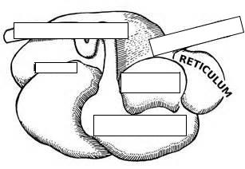

_____________ _______________ _______________ _______________
Dairy Genetics and Judging Skills

- The Dairy Cow Unified Score Card classifies traits on which a classifier base’s a cow’s score. Each trait is broken down into body parts to be looked at and ranked. What are these four traits?

- Describe proper udder traits:

  - Name two important factors to consider when looking to purchase a genetically sound bull.

  - Name one strength and how do you display this in the show ring?

  - Name one weakness and how you minimize this in the show ring?

1 0

Judging Skills

- Cow Pictures from magazines and/or cow from the farm

    - Place Cow (1-4)

  - Why did you place them this way?

_______________________________________________________________________________________________________________________________________________________________________________________________________________________________________________________________________________________________________________________________________________________________________________________________________________________________________________________________________________________________________________________________________________________________________________________________________________________________________________________________________________________________________________ 1 1
Dairy Record of Health

Fill out 1 of these forms for each dairy animal you exhibit.

Animals(s) Name/I.D.#

Starting Date
of Week | Care Given | Care Giver

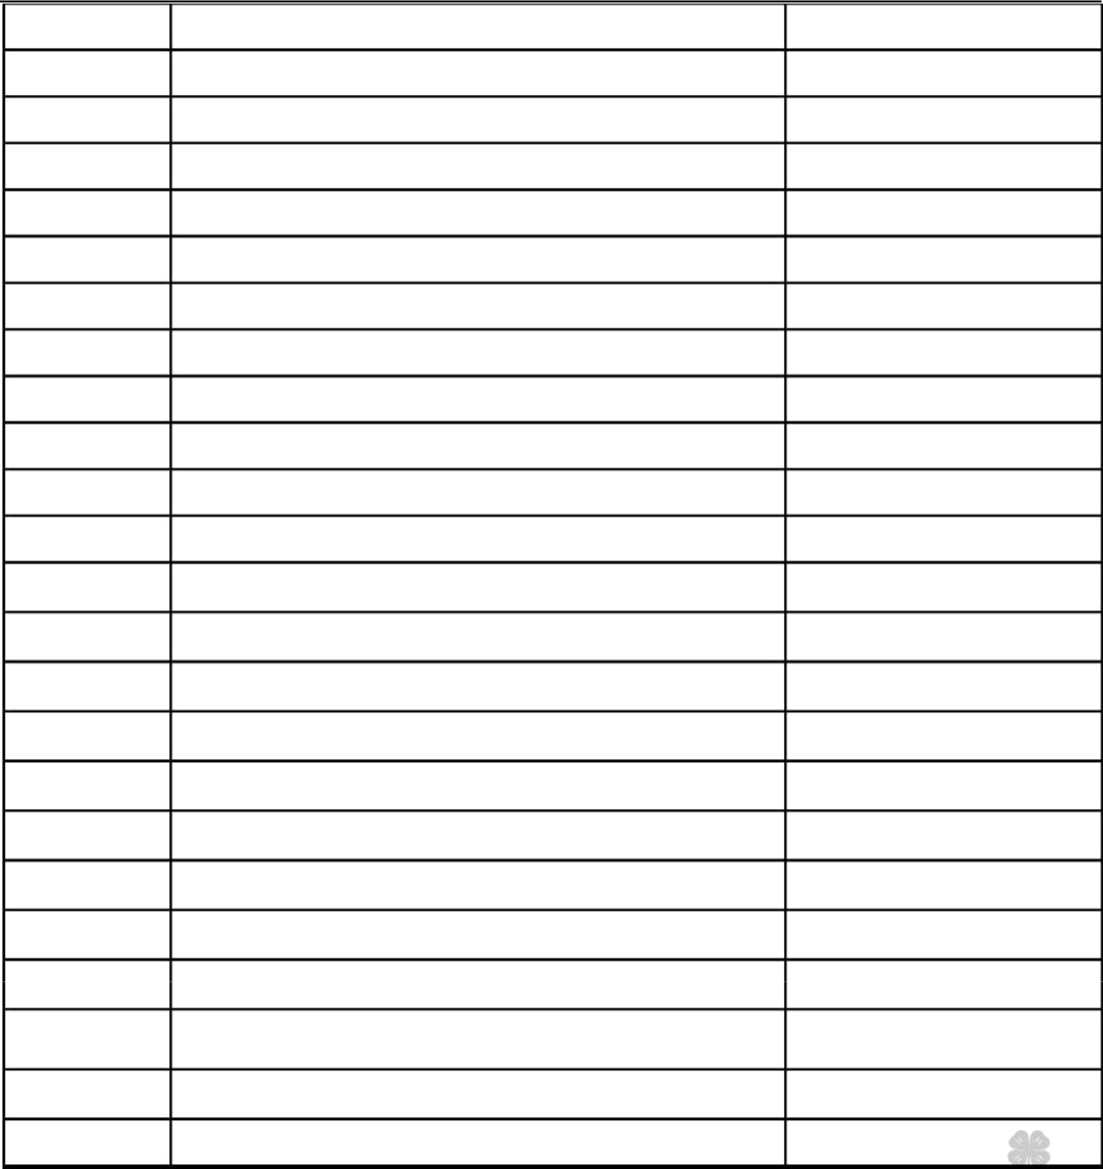

12

Dairy Record of Health

Fill out 1 of these forms for each dairy animal you exhibit.

Animals(s) Name/I.D.#

Starting Date
of Week | Care Given | Care Giver

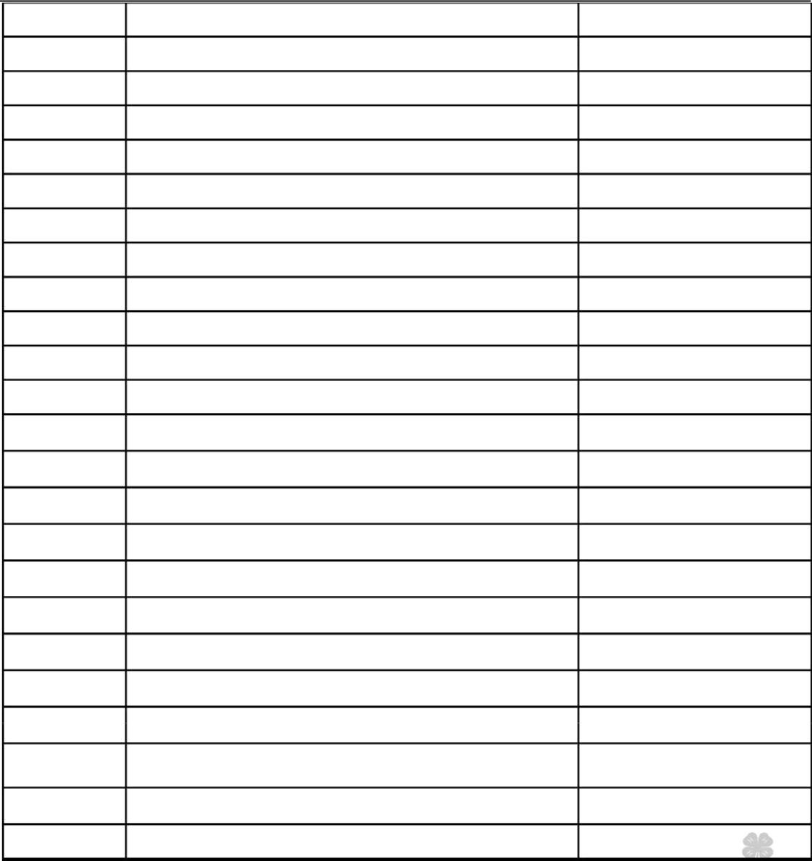

1 3

Dairy Record of Health

Fill out 1 of these forms for each dairy animal you exhibit.

Animals(s) Name/I.D.#
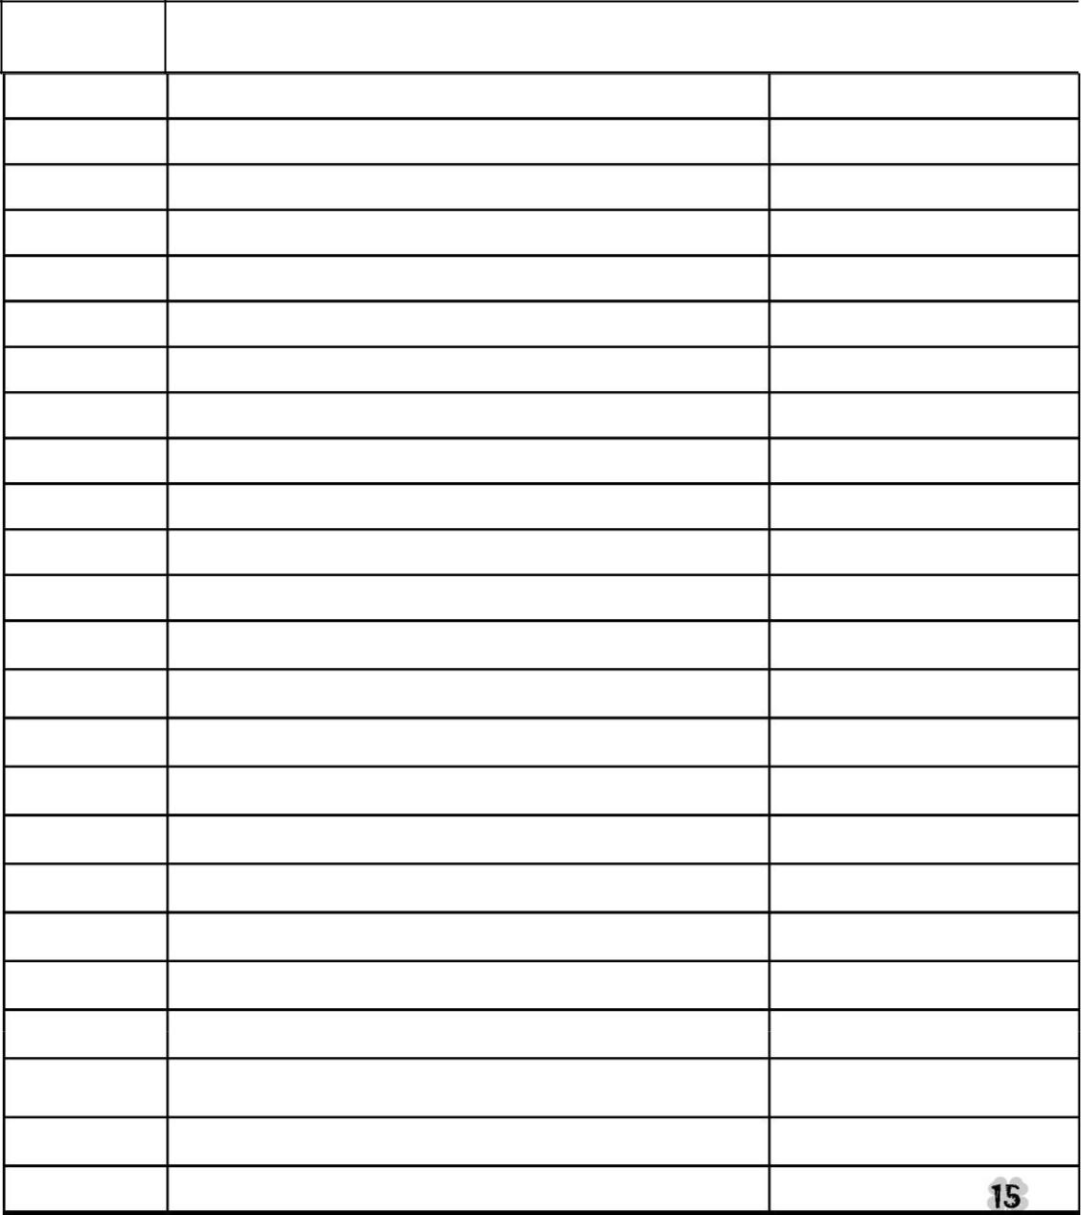

Starting Date
of Week | Care Given | Care Giver

- If your animal(s) is being raised on your own property, please have your parent or guardian sign acknowledging that you provided the care to the animal(s) and completed the dairy farm work as recorded.

- If you are borrowing an animal from someone else have the owner sign acknowledging that you provided the care to the animal(s) and completed the dairy farm work as recorded.

I, _______________________________________, do attest and certify that this 4-H’er cared for this animal in a (Property Owner’s Name (please print)

responsible manner while housed on my property and completed the works tasks listed above. I also understand that integrity and responsibility are important to the 4-H experience.

___________________________________________________ Signature of Property Owner

____________________________

Date

_________________________________________________ Signature of 4-H Member

___________________________ Date

My 4-H Dairy Project Record Book Score Sheet 4-H

Member:

4-H Club:

 |  | Possible | Your
Page |  | Points | Points
1 - 2 | COVER SHEET & WHY KEEP RECORDS PAGES | 5
 | Information neat and complete/signed by leader
3 | DAIRY PROJECT SUMMARY | 10
 | All information is neat and complete. All questions are
 | answered.
4 | DAIRY PROJECT PHOTOS | 5
 | Includes photographs of project animal(s). Captions
 | included with pictures.
5 | NAME THE PARTS | 10
 | Completed Correctly.
6-8 | MANAGEMENT RECORDS | 10
 | All information complete for each project animal.
9 | RECORDS QUESTIONNAIRE/UDDERLY TRIVIA | 10
 | All questions answered correctly.
10 | DAIRY GENETICS AND JUDGING SKILLS | 10
 | “
 | All questions complete.
11 | DAIRY COW UNIFIED SCORE CARD | 10
 | Completed correctly.
12 | DAIRY SHOWMANSHIP | 10
 | All questions complete
13-15 | RECORD OF CARE | 10
 | Information complete.
16-17 | DAIRY FARM WORK RECORD | 10
 | Information and signature complete.
 | TOTAL Points
 | A: 100-85, B: 84-75, C: 74-60, No Rating: 59-0

1 8

MSU is an affirmative-action, equal-opportunity employer. Michigan State University Extension programs and materials are open to all without regard to race, color, national origin, sex, gender, gender identity, religion, age, height, weight, disability, political beliefs, sexual orientation, marital status, family status or veteran status.

