Dairy Project Record Book
Junior (Age 8-11)

Do NOT put this record book in a binder.

Name:

4-H Club:

4-H Leader:

Michigan State University Extension programs and materials are open to all without regard to race, color, national origin, gender, religion, age, disability, political beliefs, sexual orientation, marital or family status.

Age (as of 1/1): Years in 4-H Dairy Project:

Revised 4/2014

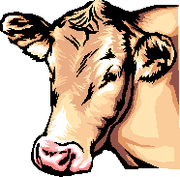
Why Keep Records?
Members learn more about their project animals
- costs, feed, health and management skills. Documents activities and progress in the project. Improves management and production practices. Helps plan future projects.

Keep this record as part of your Personal 4-H Records.
This information is helpful in applying for 4-H awards and scholarships. Remember - records are no better than what YOU put into them!

Dairy Leader’s Signature:

Extra Credit for my Dairy Project?
An outstanding 4-H project record is one that goes above and beyond what is expected. Be creative!

Ionia

A completed record book should have a beginning and final photograph. You are encouraged to be in the photo with your project animal(s) and to include more photographs. Include captions. You may use additional pages.
Write a report on a related topic of at least one page:

County | Proper Care and Nutrition; Selection; Animal Science; Safe Management Practices or Diagram of Farm Set-up; Veterinary Science; Food Products (such as sample “healthy” recipes) of cheese or milk, etc.  MSU Extension 50 E. Sprague Rd. Ionia, MI 48846  Phone: (616) 527—5357  Fax: (616) 522—1449

2

Dairy Project Summary

Number of years in the Dairy Project, including this year?

Number of project meetings held: Number I attended: I attended project talks or demonstrations.
Topics were:

Have you participated in other dairy activities? Yes No If yes, list the activities, shows, fairs or related programs attended:

What were the three most important things you learned this year about Dairy?

What are your goals for this year’s dairy project?

3

Dairy Project Photos

Be creative. The more photos, the better! You are encouraged to be in the photo with your Dairy project animal(s). You should also include captions on your pictures that at least include the date of the photograph.

4

Name the Parts
All ages

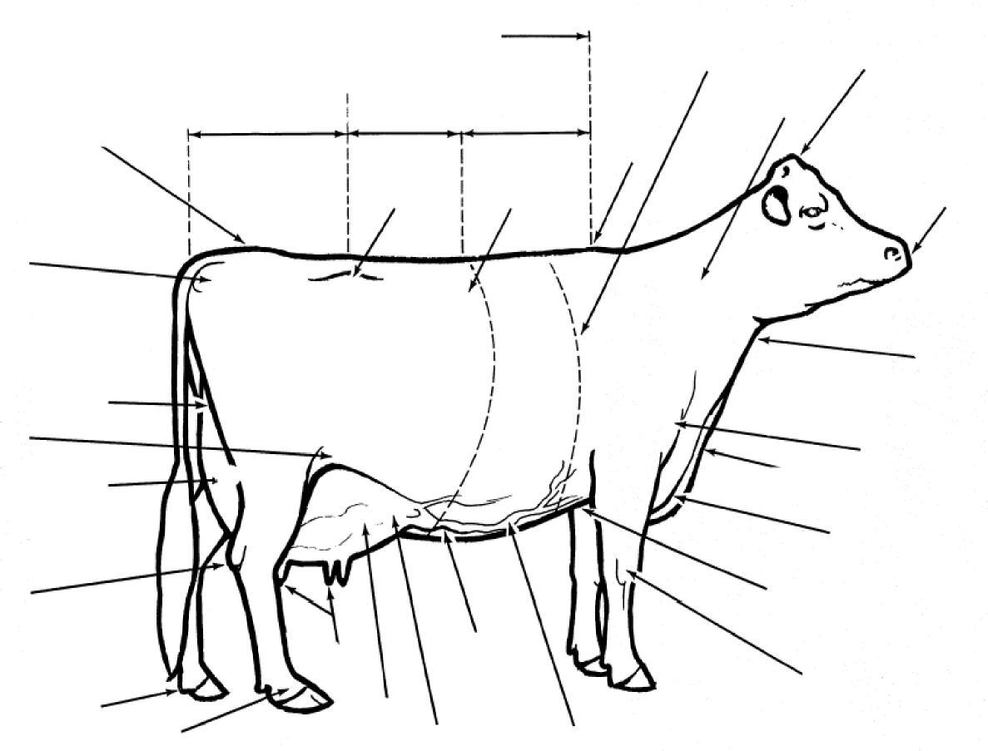
Write the part number on each line.

- Muzzle
- Hip
- Dewclaw
- Brisket
- Throat
- Dewlap
- Knee
- Flank
- Pin Bones
- Heart Girth
- Back
- Rump
- Mammary Veins
- Poll
- Rear udder
- Rear udder attachment
17. Neck
18. Chine
19. Teats
20. Point of Shoulder
21. Foreudder
22. Foreudder attachment
23. Tail Head
24. Loin
25. Milk Wells
26. Hock
27. Chest floor
28. Pastern
29. Barrel
30. Withers

Management Records

Fill out 1 of these pages per dairy project (You may have leftover pages)

Name: | Breed: | Control or ID Number:
Date of Birth or Age: | RFID (required): Tatoo: Left -  Right-

How often do you feed/water your project?
What does your animal’s feed consist of?
What type of bedding do you use for your dairy project?
What is your dairy project?
How often is the pen/barn your animal stays in cleaned? How do you do this?

Management Records

Fill out 1 of these pages per dairy project (You may have leftover pages)

Name: | Breed: | Control or ID Number:
Date of Birth or Age: | RFID (required): Tattoo: Left – Right -

How often do you feed/water your project?
What does your animal’s feed consist of?
What type of bedding do you use for your dairy project?
What is your dairy project?
How often is the pen/barn your animal stays in cleaned? How do you do this?

7

Management Records

Fill out 1 of these pages per dairy project (You may have leftover pages)

Name: | Breed: | Control or ID Number:
Date of Birth or Age: | RFID (required): Tattoo: Left - Right -

How often do you feed/water your project?
What does your animal’s feed consist of?
What type of bedding do you use for your dairy project?
What is your dairy project?
How often is the pen/barn your animal stays in cleaned? How do you do this?

8

Records Questionnaire
Questions refer to the farm or herd where your animals are housed.
What breed(s) of cattle does the farm have?
How many lactating cows does the farm have? How many dry cows does the farm have?
Total number of heifers and calves on farm?
At what age are calves weaned off milk at this farm?
“Udderly” Fun Matching
Match the words below with the descriptions

A cooling tank where all of the milk from the farm is stores:
The average Guernsey produces...
A cow is dry (not producing milk) for an average of ... A cow milks for approximately ...
Silage is ...
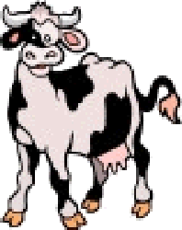
Holsteins are the highest producers of... Jerseys are the highest producers of... Colostrum is...
Forages are ...
A calf is milk fed for...
An animal with four stomach compartments:

- Grass or hay used for feed
- Pounds of Milk
- 6-7 Gallons
- Grass compacted & stored in airtight conditions
- 305 Days
- Bulk Tank
- 60 Days
- Butter fat
- The first milk after calving
- 7-8 weeks

Dairy Project Showmanship
Preparing for the Show Ring
- What are 3 basic tips you could give someone about washing a dairy project?

- What do you find most difficult about clipping your dairy project?

- What did you do to prepare your project for show?
Safety Techniques
- Dairy cattle are color blind and have poor depth perception. What safety issues might this cause?

- Dairy cattle are highly unpredictable, how do you safely approach your animal?

- Name 3 things you should be aware of on the farm. (vehicles, animals, etc.)
In the Show Ring
- What items are important to you in your dairy project show box?

- What type of clothing might you wear in the show ring?

10

Dairy Project Showmanship
How should a dairy cow’s feet be set under them when in the show ring? Specify the differences for dairy cows, heifers and bulls. Place name on line.

__________________________________
________________________________________________________________________________________________________________________________________________________________________________________________________________________________________________________________________________________________________________________________________________
________________________________________________________________________________________________________________________________________________________________________________________________________________________________________________________________________________________________________________________________________________
__________________________________
________________________________________________________________________________________________________________________________________________________________________________________________________________________________________________________________________________________________________________________________________________

_________________________________

Dairy Farm Work Record
Record all of the work you completed for the farm that your dairy project is raised on. For example, what are your farm responsibilities apart from taking care of your 4-H dairy animal? The property owner’s
signature on the second page is mandatory.

Description of Work Completed | Number of Hours Spent on Task

Dairy Farm Work Record (continued)

Date(s)
Description of Work Completed | Number of Hours Spent  on Task

If your animal(s) is being raised on your own property, please have your parent or guardian sign acknowledging that you provided the care to the animal(s) and completed the dairy farm work as recorded.

If you are borrowing an animal from someone else, have the owner sign acknowledging that you provided the care to the animal(s) and completed the dairy farm work as recorded.

I, , do attest and certify that this 4-H’er
Property Owner’s Name (please print)

cared for this animal in a responsible manner while housed on my property and completed the works tasks listed above. I also understand that integrity and responsibility are important to the 4-H experience.

Signature of Property Owner Date

Signature of 4-H Leader Date

My 4-H Dairy Project Record Book Score Sheet 4-H Member:

4-H Club:

Page |  | Possible Points | Your Points
1-2 | COVER SHEET/WHY KEEP RECORDS | 5
 | All information is complete/signed by leader
3 | DAIRY PROJECT SUMMARY | 5
 | All information is neat and complete. All questions are answered.
4 | DAIRY PROJECT PHOTOS | 10
 | Includes photographs of project animal(s). Captions included with pictures.
5 | NAME THE PARTS | 15
 | Completed correctly.
6-8 | MANAGEMENT RECORDS | 15
 | All information complete for each project animal.
9 | RECORDS QUESTIONNAIRE | 5
 | Show record complete and questions answered.
9 | “UDDERLY” FUN MATCHING | 5
 | Completed correctly..
10 | DAIRY PROJECT SHOWMANSHIP“ | 10
 | All information completed.
11-13 | RECORD OF CARE | 15
 | Information complete.
14-15 | DAIRY FARM WORK RECORDE | 15
 | Information complete and signed by leader.
TOTAL Points
A: 85- 100, B: 75 - 84, C: 60 - 74, No Rating: 0-39

16
MSU is an affirmative-action, equal-opportunity employer. Michigan State University Extension programs and materials are open to all without regard to race, color, national origin, sex, gender, gender identity, religion, age, height, weight, disability, political beliefs, sexual orientation, marital status, family status or veteran status.

