Managing Archived Members
Before You Start
Member Records should only be archived if the member will not be returning to participate in the program for the foreseeable future. Approved members may not be archived. If a member has an incomplete or submitted enrollment, the enrollment must be sent back and deleted before being archived.

Archiving Member Records  - Click on the member profile from the Member Search. | Screenshots  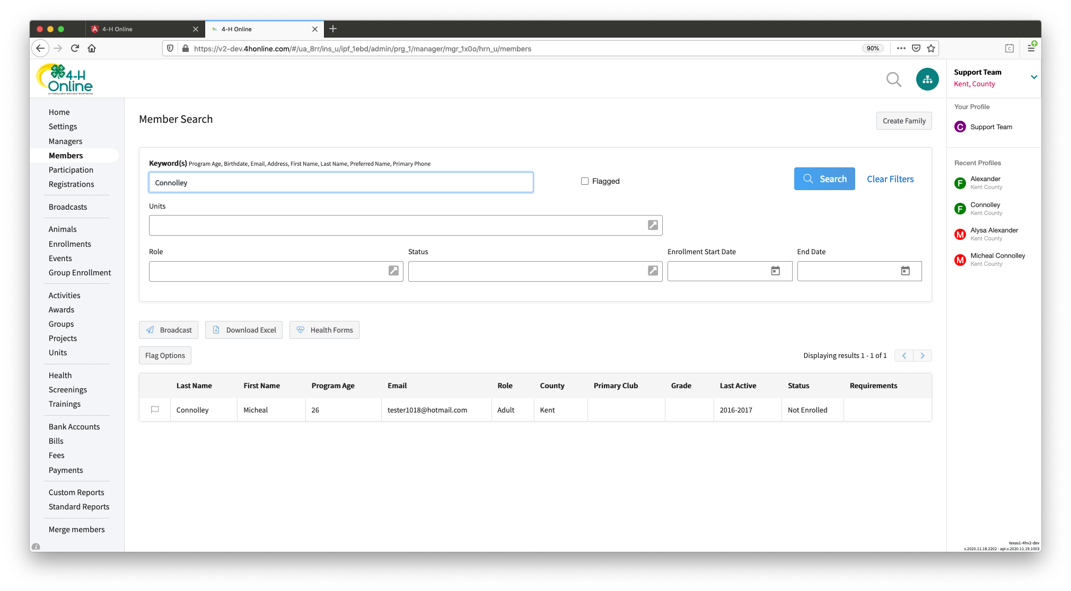  (Screen appearance may vary per state)
- Click on the Profile tab within the member record.
- Scroll to the bottom of the page and click the orange “Archive” button.
- Confirm that you would like to archive the member.
- The member will appear to the bottom right of the family member list.

Un-Archiving Member Records

- Click on the archived member record from the Member Search.
- Click on the Member List page in the member’s record.
- Click on the archived member record in the blue box at the bottom right of the screen.
- Scroll to the bottom of the Member Profile page.
- Click the gray “Reactivate” button in the bottom left corner.

- Confirm that you would like to Reactivate the member.

- The member record will appear on the member list ready to enroll for the year.

