Recording Event Payments Received in County Office
Before You Start
Be sure to only mark the payment for members as being received when it has been turned in to the office.

Steps  - Click on Events in the navigation pane.  - Click on the Payment Due subtab. | Screenshots  (Screen appearance may vary per state)  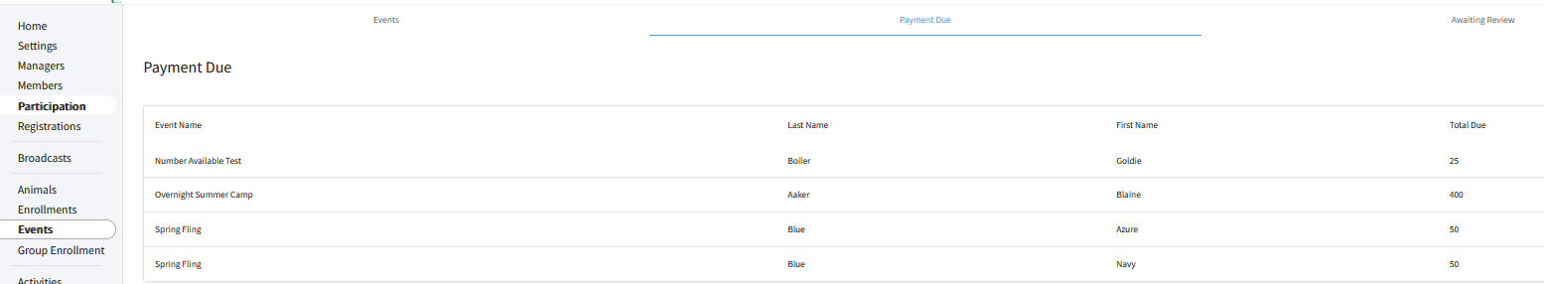
- The list of members that have submitted enrollment and indicated they would make payment to the county office is listed. Click on a member name to record their payment information when it has been received.  - Select the items that have been received.  - Select the date the payment was received.  - Use the Payment Note field(s) to record the check number or that it was a cash payment, receipt number, or any other notes that you need to keep record of according to your state’s policies (such as if a Club has paid the fee on behalf of the family).  - Click the Approve button.  - Payments should only be recorded after they have been received from the family for accurate record keeping. | 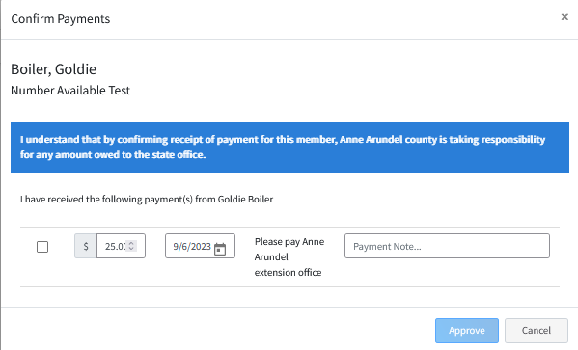
Tips
At the time a County Manager marks a payment as received, they are confirming that they have received the payment and are taking responsibility for any amount owed to the State Office or the County Office that created the event.

