Manager Account Sign-in
Before You Start
- Manager accounts must be created and permissions set by the program’s System Manager before the manager may login to their account.
- The Manager account email address must be a unique email address. It may not be associated with a family profile.

Steps  - Go to https://v2.4honline.com  - Enter your email address.  - Enter your password.  - Click the Sign in button. | Screenshots  (Screen appearance may vary per state)  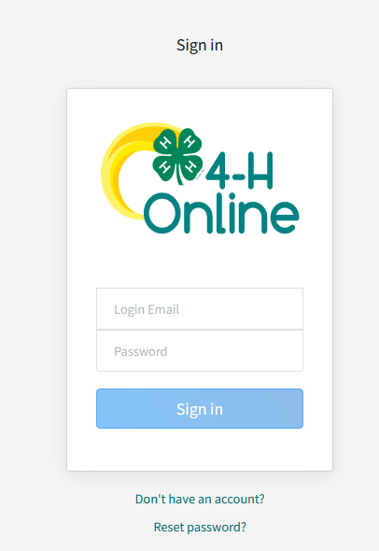
Manager Password Reset

Before You Start
- Managers may reset their password from the login screen at any time.
- If at any point a Manager receives a notification that their password has expired, they should follow these steps to set a new password.
- Go to https://v2.4honline.com.
- Click Reset Password? Below the sign-in box.

- Enter your manager account email address.  - Click “Reset your password”.  - An email will be sent to the email address entered.  - The email will contain a link to reset the password on the manager account.  - After clicking the link, the manager will enter and confirm their new password.  - Once the new password has been set, the manager will login normally with their updated password. | 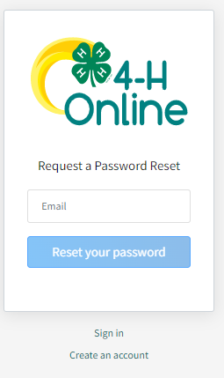
Tips
- Passwords of twelve (12) characters or less will expire after 180 days.
- Passwords of thirteen (13) characters or more will expire after 1 year.

