Creating Activities
Before You Start
Both Institution and County Managers can create Activities. Institution managers can create program-level activities, while County managers can create county-level Activities.

Steps  - Click on the Activities tab in the navigation pane.  - Click on the “Add Activity” button to add an activity to the list. | Screenshots  (Screen appearance may vary per state)  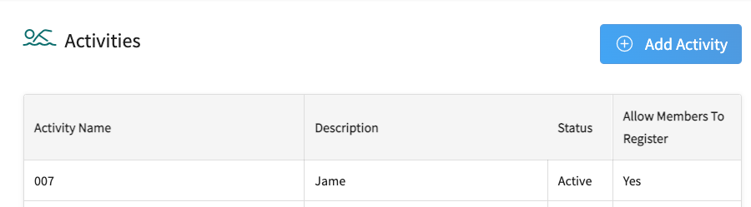
- Enter the name of the Activity.  - Enter a description of the Activity.  - Enter the status of the Activity. (Active, Deleted, or Inactive)  - Enter a code (optional).  - Select whether members are allowed to register for this activity. If un-checked, managers must add the entry to the member record.  - Click the Save button. | 