Basic Navigation Tips
Global Search
Not numbered or bulleted by default.

Steps  - At the top of every screen, you will see a gray magnifying glass. Click on this from any screen to search for a member, family, invoice, email address or event registration.  - Click on the record you would like to access and click View. | Screenshots  (Screen appearance may vary per state)  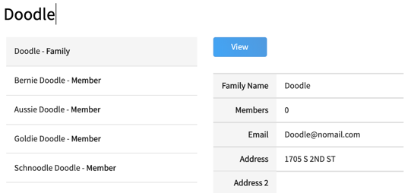  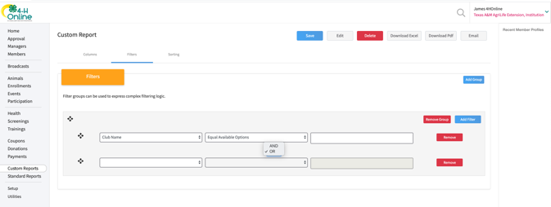
Return to a Recent Member Profile
- To return to a member’s profile that you have recently viewed, click on the member’s name in the right-hand pane titled Recent Member Profiles.  - If you do not see this pane, try to zoom out in your browser (ctrl + - ).  NOTE: You will not see this pane while you are logged in to a member or family profile. | 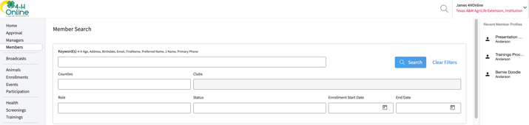
Return to the Manager Account
- When you click to view a member from the Member Search or the Global Search, you will land in the family or member profile.  - Click the orange up arrow at the top right to return to the Manager account. | 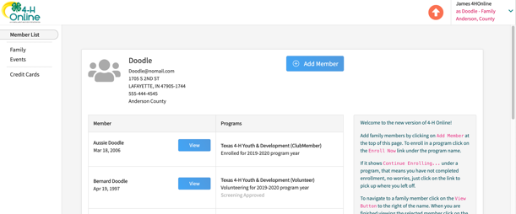

Switch to a Different County
- If you have been assigned permissions for more than one County or are a District, Region or Institution Manager, you may navigate to a different account for which you have permissions by clicking on the drop-down next to your name at the top right of the screen.  - Select Change Hierarchy. | 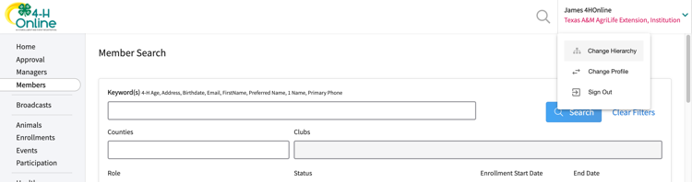
- Navigate to the area of the hierarchy that you would like to switch to.  - Click Save.  NOTE: You will only see areas for which you have permission. | 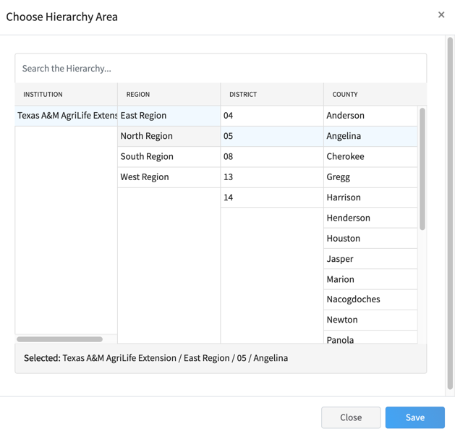
Switch to a Different Manager Account
- If you have both a System Manager and an Institution Manager account, to switch from one to the other, click on the drop-down menu at the top right corner next to your name.
- Select Change Profile.
- Select the Profile that you would like to access.

