Marking an Individual as Not Participating
Before You Start
County and Institution Managers may change the participation status of a member with an approved enrollment to Not Participating. Changing a member to Not Participating will not refund any fees.

Steps  - Click on Enrollments in the navigation pane.  - Search for the Member in the Approved Members search.  - Click on the Member’s record and scroll to the bottom of the page. | Screenshots  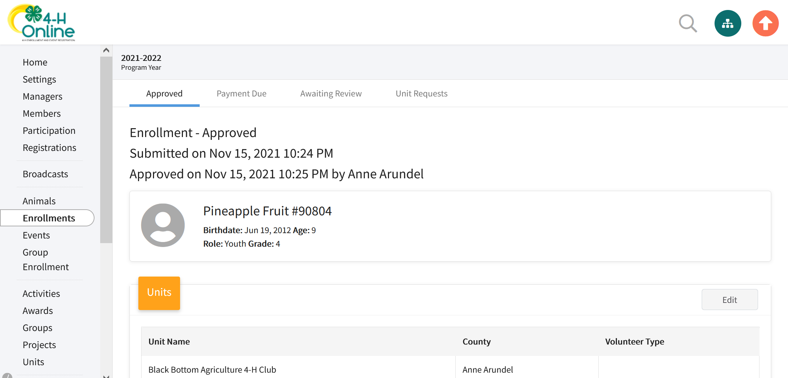  (Screen appearance may vary per state)
- Click the Not Participating button. | 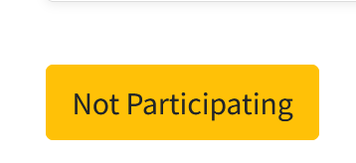
- A popup window will appear. Click the Confirm button to change the member’s status to not participating. | 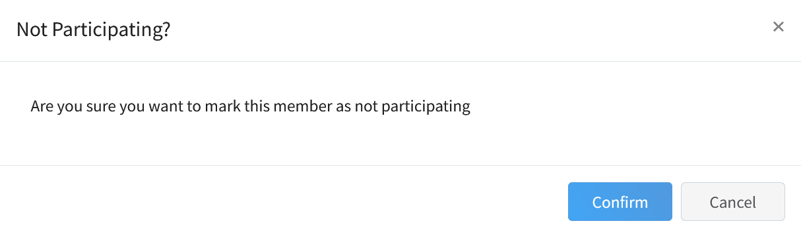
Removing a Member from Not Participating Status
- Click on the Members in the navigation pane.
- Search and select the member record.

- Click the Mark As Participating button.
- The member record will return to approved status.
Tips
Changing a member to Not Participating will mean that their approved enrollment will still count on the ES-237/annual report.
Members marked as Not Participating will not be able to register for events.
Marking a member as Not Participating will not impact the member’s ability to re-enroll in future program years.
Changing the status to Not Participating or returning it to Approved status only applies to enrollments for the current program year.

