Creating An Event
Before You Start
Event registrations that require County Approval are approved by the member’s primary club county.

The minimum required steps are to create the event, set up registration types with registration dates and set the event to Active status.

Depending on the needs of your event, you may also need to create event coupons, sessions/contest tracks, set up custom questions, custom file uploads, associate consents with the registration type.

Steps  - Click on the Events tab in the navigation pane.  - Click the Add Event button to create a new event. | Screenshots  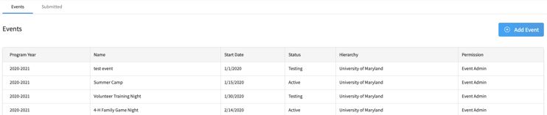  (Screen appearance may vary per state)
- Enter the name of the event.  - Enter the Event Description.  - Select the program year in which the event will occur.  - Enter the Event Start Date.  - Enter the Event End Date.  - Click Add. | 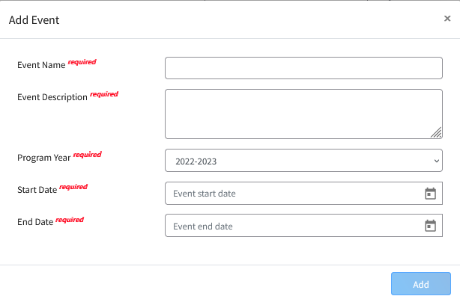
- Review the Event details.  - Click the Edit button to modify the event details if needed.  - Ticketing Enabled – This feature is under development. It will allow tickets to be printed with a QR code once available.  - Sessions Enabled – This feature allows multiple tracks within a single event. Custom questions can be created to only be asked of registrants choosing the associated session.  - Allow Registration by Manager Only – Restricts the registration of members for the event to be entered by Managers only; families may not start nor submit their own registration.  - Allow Multiple Registrations – allows an individual to register for the event multiple times. Often used if it is an entry-based registration for animals tied to the event; member submits an event registration and associates which animal is linked to the registration.  - Payment Credits On – this is the option for families to pay by check/cash.  - Electronic Payments On – the option for families to pay by credit card.  - If the event registrations need to be approved by a manager, select the level(s) of manager approval required. The Program level option requires approval by an Institution Manager.  - If you do not want the system emails to go out related to registrations in this event, check the box to Disable Automated Emails  - Click the Save button when you are done making changes to the event details. | 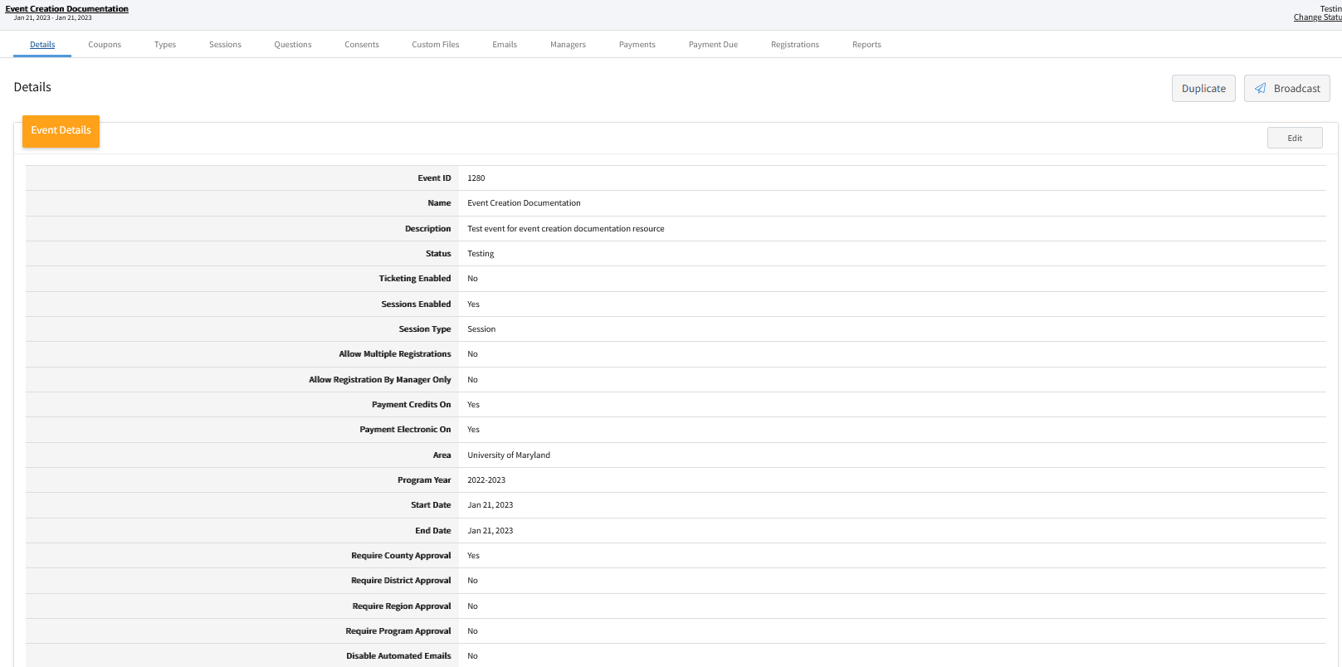
- If you wish to create a custom URL for the event, click Edit for the Public Facing Event section.  - Enter your unique vanity domain for the event. It will not display after saving if the vanity domain is already in use for another event.  NOTE: The vanity domain may only contain letters, numbers and the dash character. Event Managers should consider including the State or County and State name in the custom URL to make it clear to the general public and members that they are registering for the correct event. | 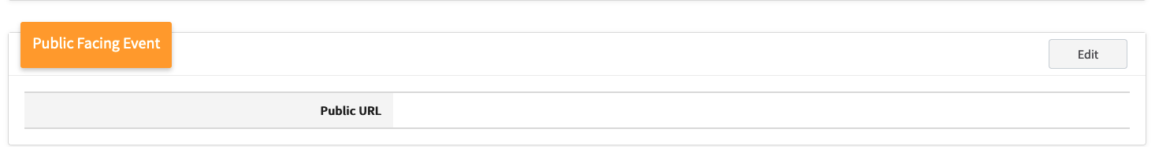
- If you need to restrict which county members, based on their primary club county, may register for the event, click Edit on the Open/Restrict Event by County. You can add or remove counties to the list of which county’s members can register. Click save after adjusting the list.  NOTE: If the event will be open for the general public to register (Participant role), then the event must be shared with all counties. This applies to all events.  - You may upload a logo image for your event. When a family selects to register a member for the event, the logo is in the upper left corner next to the name of the event.  - You may upload a Splash image for your event. For events visible at the bottom of the family’s Member list screen, the splash image is the large photo located above the Register button. | 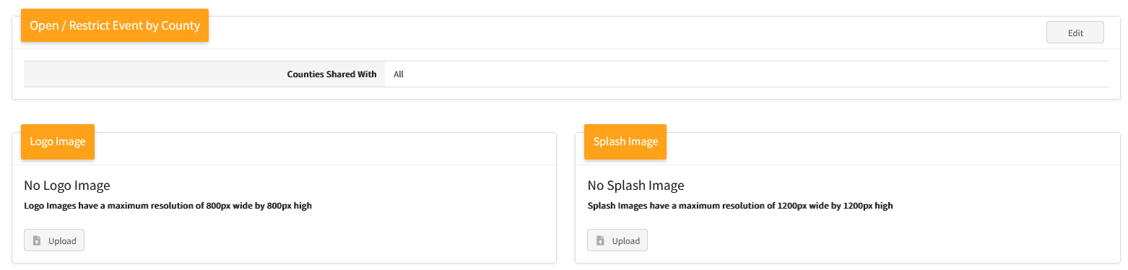

Creating Event Registration Types
Before You Start
Take some time to plan out the registration type(s) needed for the event. Think through the following questions to identify the minimum requirements.
- Which member roles can register?
- Can registrants that had an approved enrollment for the prior program year to register?
- Are their restrictions for which enrolled Youth Members can register for the event? (Age, Grade, or 4-H Youth Division) These restrictions are not able to be applied to individuals with a Participant role.
- Click on the Types sub-tab.  - Click the Add Type button. | 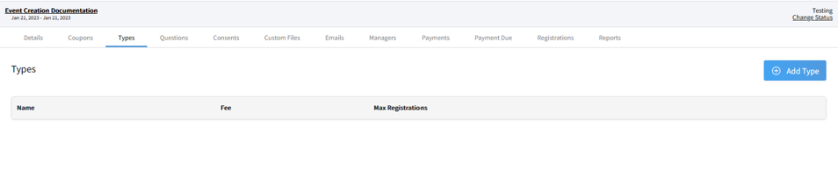
- Enter the name of the Registration Type. Make sure the name is unique for every registration type you add to the event. The registration type name is visible to individual registering for the event, so make sure the name is clear and concise.  - Select the Role for the registration type.  - Select the type of Health Form to be associated with the registration type.  - If applicable, enter the number of maximum registrations allowed for the type. If there are no limits, leave the value at 0.  - Allow Active in Previous Program Year – Check this box if you want to allow members that had a fully approved enrollment in the prior program year to register as the registration type, even if they do not have an approved enrollment in the current program year.  - If registrations for this type may only be initiated by managers, check this box.  - If a deposit is required, check the Deposit Required box. Steps 10 and 11 are required if a Deposit is marked as required.  - Enter in the Deposit Amount  - Enter the Deposit Full Payment Due Date – this is the last date the deposit payment can be made. Full payment for the registration is required before the start of the event so that it is fully approved and paid.  - Set the Registration Start Date  - Set the Registration End Date  - If allowing Early registration – select this box, and enter the Early Registration Fee, and Early Registration Start and End dates. It should not overlap with the regular registration date.  - If allowing Late Registration, select this box. Enter the Late Registration Fee, Late Registration Start and End dates. It should not overlap with the regular registration period.  - If you need to restrict the registration type to a specific Youth Division or by Program Age or Grade, select the corresponding option for the Youth Registration Type menu. Additional fields will appear based on your selected option.  - If animals are to be associated with the event registration for the registration type, select the corresponding Animal Type. This will allow the member to select the animal they have previously identified in 4-H Online to be associated with the registration. Only one animal may be linked per registration. In this case be sure that your Event Detail Allows Multiple Registrations if members may register more than one animal for the event. | 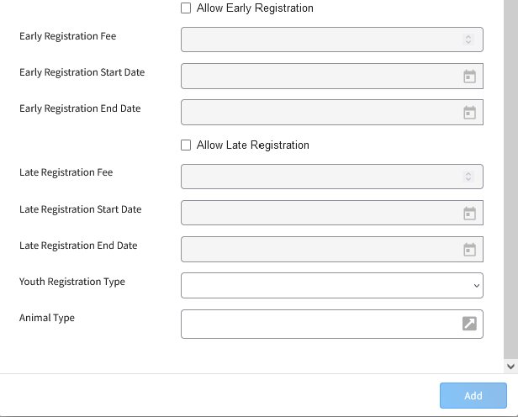  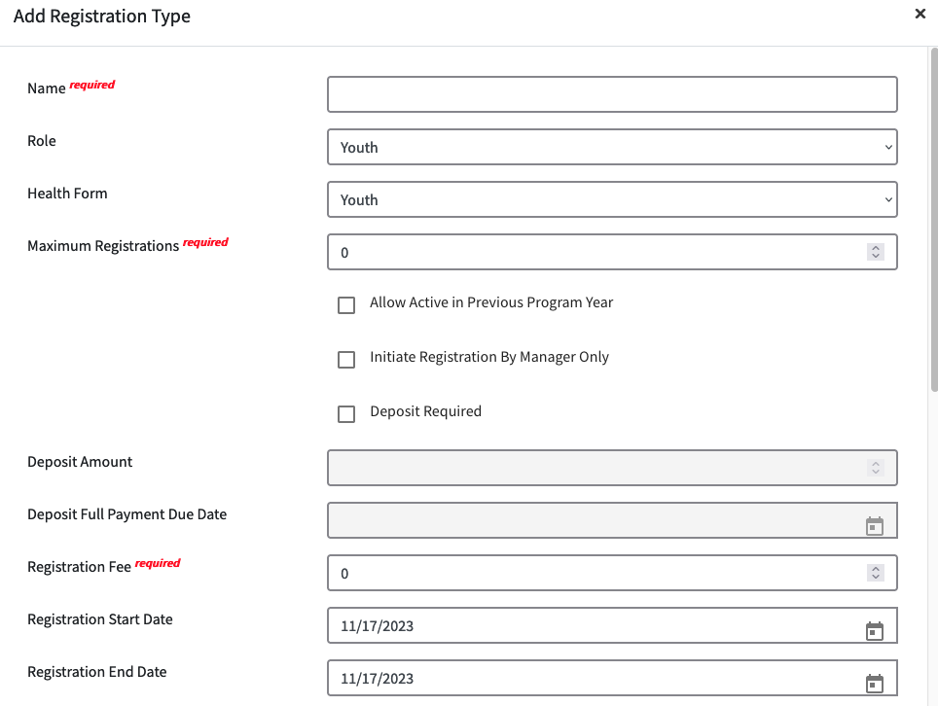

Event Sessions/Contests (Optional)
Before you start
- Events may have multiple sessions (or contests) as part of the event setup. The Session/Contest can be thought of as an event with multiple tracks or the same program is offered on multiple dates; where members may register for one or more sessions/contests. DO NOT use Sessions/Contest if your event is only a single offering. Session/Contest selection is not required for registration, and may be skipped.
- Custom Questions may be applied to the registration type if all members of that type need to answer the question without regard to their session selection OR you may associate the custom question to a specific Session/Contest.
- A member’s session selection may not be modified/changed on approved registrations.
- Deleted registrations still count towards the session/contest maximums.
- On the Details tab, make sure the checkbox for Sessions Enabled.  - When this is enabled, there will be a tab added to the screen for Sessions. | 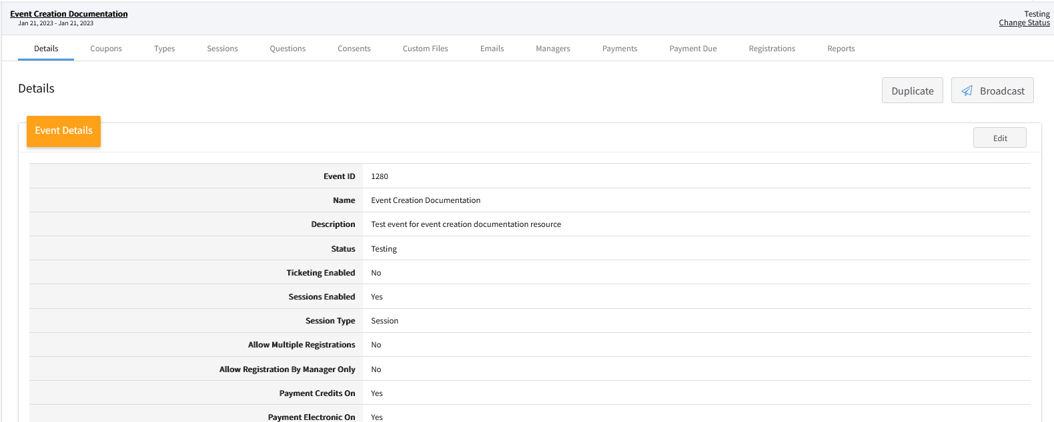
- Click on the Sessions tab.  - Click the +Add Session Button. | 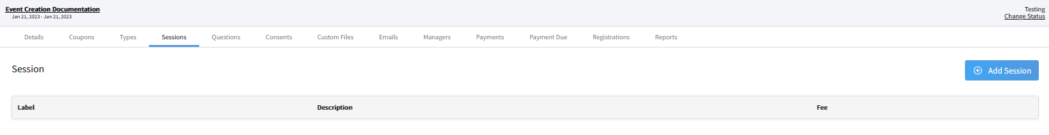
- Enter in the maximum registrations; leave the value at 0 if the session/contest allows unlimited registrations.  - Enter the name of the session/contest.  - Enter a description of the session/contest.  - Enter the Fee associated with the sessions/contest selection. If the registration fee has already been applied to the registration type, leave the value at 0.  - Select the Registration Type(s) that may register for this session/contest.  - Click the Add button.  - Repeat Steps 4 – 10 for each session/contest added to the event. | 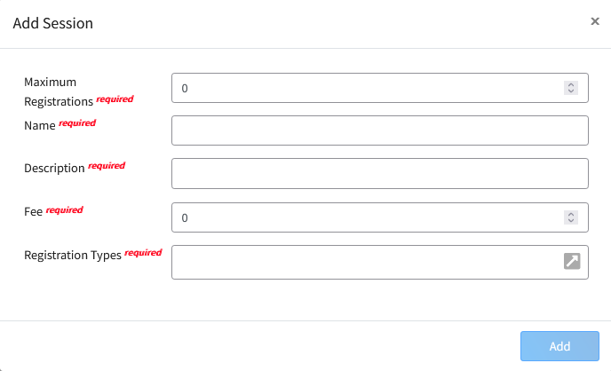

Creating Custom Event Questions
Before you start
Plan out the question(s) that you need to ask for each registration type.
- Is it a question that the registrant is required to answer?
- Determine which type of question format best works for the question you need to ask. In many cases, the same question can be asked in a few different formats.
- Click on the Questions tab in the event.  - Click the + button to add a question. | 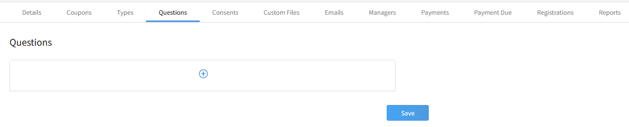
- Clicking on a question type will allow you to see a preview. Controls marked with a $ are question types that may have fees associated with responses to the question.  - Checkbox – Single option (not recommended for Yes/No questions)  - Content Block – Text information, no registrant input  - Date Picker – Date field  - Dropdown – Menu of selections, registrant selects one response  - Multi-Line Text – Long text response  - Multiple Choice – Multiple responses may be selected  - Number Input – Numerical response  - Radio Group – Single response selection (use this for Yes/No questions)  - Single-Line Text – Short text responses  - Quantity Control – Allows the manager to set a limited quantity number available for registrants to select.  - After selecting your control type, click the Add button. | 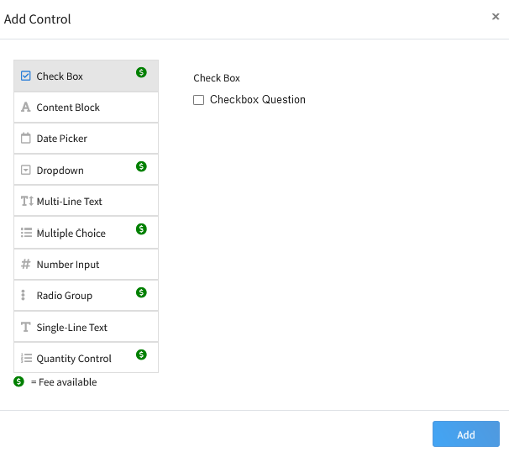

- Enter your question text into the Question field.  - Enter the Report Label – this is a short label that will display on reports as the column heading (i.e., Shirt Size, Fruit, Entree).  - Enter the Response options. Click the Add Option button if you need to add additional options. Click the trash can icon to remove the response option.  - If you would like a shorter report column label for the specific option, please enter it in the column for your option.  - If a fee applies to the option, enter the fee amount in the Fee column. Use 2 decimal places for dollar amounts (5.00 or 5.20 for example). Leave the fee column blank if there is no fee for the option.  - Archived – if the question is no longer being asked, it can be marked as archived.  - Can be Viewed by: Select each registration type that the question should be asked. At least one registration type must be selected.  - If the question is a Manager-only question, then only a Manager may enter the response. Mark the True box.  - If you marked Manager-only in step 12, then Minimum Hierarchy View and Minimum Hierarchy Edit fields will become required fields.  - Minimum Hierarchy View – Select the lowest level of the hierarchy (manager) that will be able to see the question on event registrations (County or Institution)  - Minimum Hierarchy Edit – Select the lowest level of the hierarchy (manager) that will be able to enter/modify the response.  - Click the Add button. | 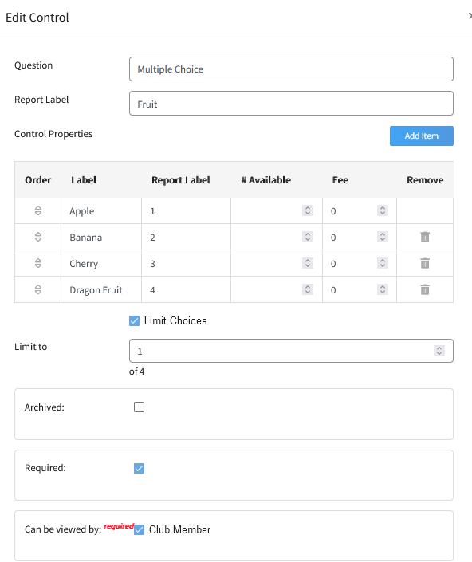  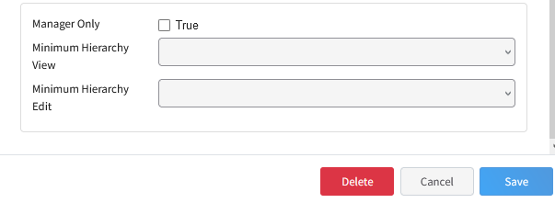

- You can rearrange the order of the questions by clicking on the question and dragging it to your preferred position in the list.  - Click Save at the bottom of the page to save the changes to the order of the questions. | 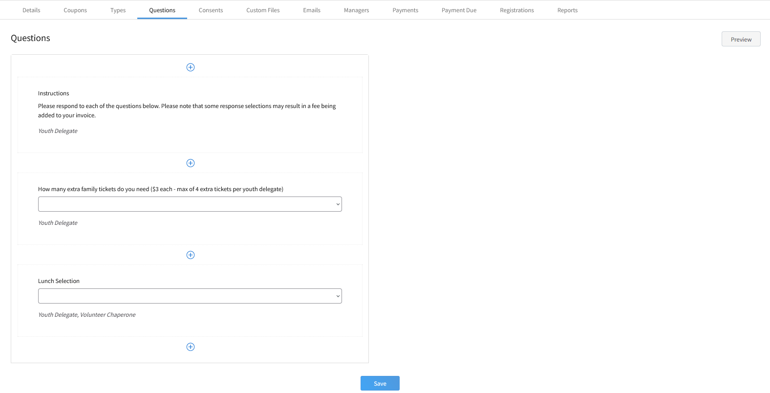
- Click the Preview button and select a registration type from the drop-down menu to see a preview of how members registering in the selected registration type will see the questions. | 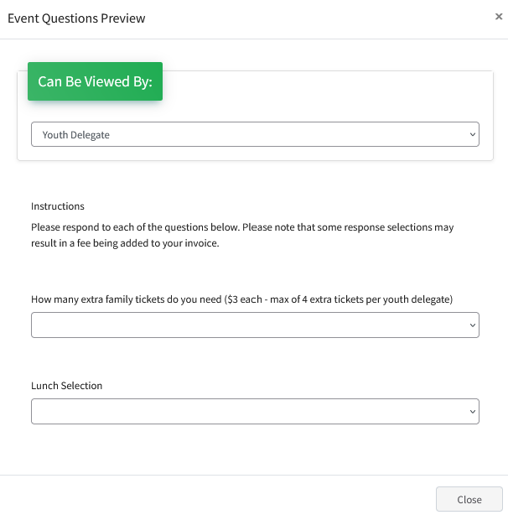

Associating Consents with a Registration Type
Before you start
You may require consents to be signed as part of the event registration process.
- If the same consent was also signed at the time of enrollment, members will need to consent again as part of the registration process.
- Event Consents may be put on event reports; whereas Enrollment Consents may not be added to event reports. You may, however, create an enrollment custom report and filter it for members that have registered for the event.
- Click on the Consents tab in the event.  - Click the +Associate Consent button. | 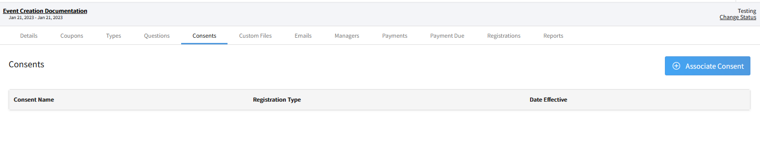
- Select the name of the Consent from the drop-down menu.  - Select the Registration type required to complete the consent.  - Click Save.  - Repeat for each Consent that each Registration type will need to complete as part of the event registration process. | 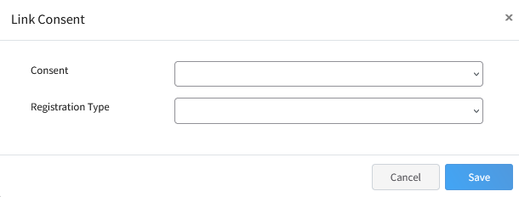

Custom Files
Before you start
Custom File uploads will appear on the Custom Questions screen within the event registration process for families. If you are adding custom files to the registration process, please be sure that you have at least one custom question (or content block) so that the families will see the custom file upload as well.
- Click on the Custom Files tab in the event.  - Click the +Add Custom File button. | 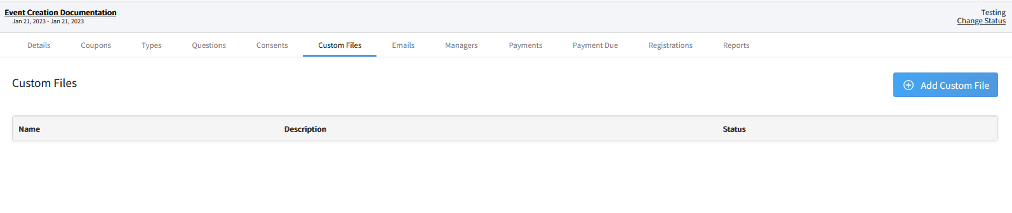
- Enter the title of the custom file.  - Enter a description of the custom file.  - Select the visibility of the file for each Registration type that is set up for the event.  - Not Visible – File will not appear for the Registration Type  - Visible – File will be visible to the registrant, but registration can be submitted without a file uploaded.  **A manager may upload the file to the event registration after it is approved.  - Required – File is required to be uploaded before the registrant can complete their registration and submit it for review.  - Click the Add button. | 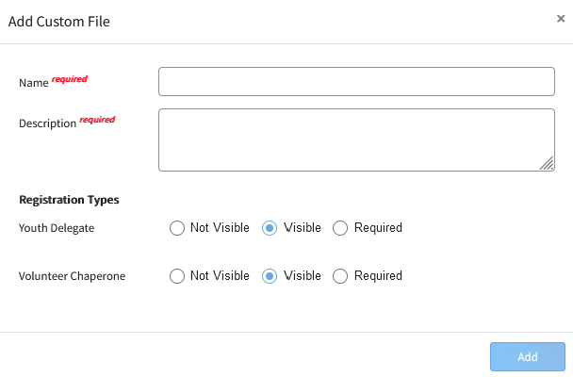
- If you need to upload a fillable PDF as a template for the registrant, click on the Custom File record.  - Click the Upload button. | 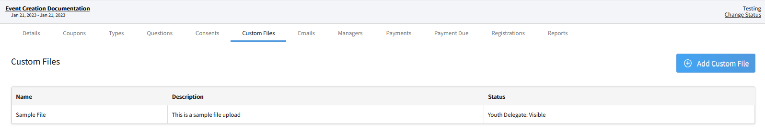  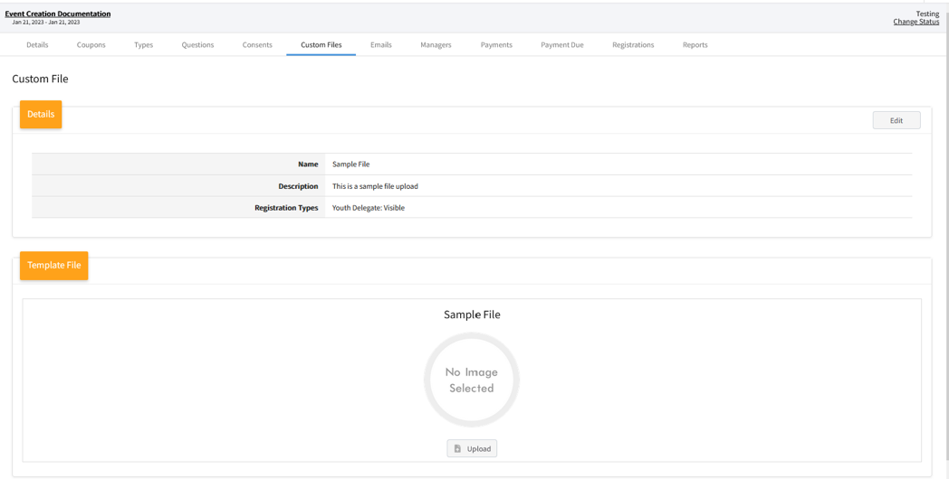

Configuring Event Emails
Event Creators/Admins may selectively determine which system emails will go out during the event registration and approval process on an event-by-event basis, as long as they haven’t disabled all Automatic Emails on the Event Details screen.
- Click on the Emails tab.  - Click Edit for the Email Configuration section. | 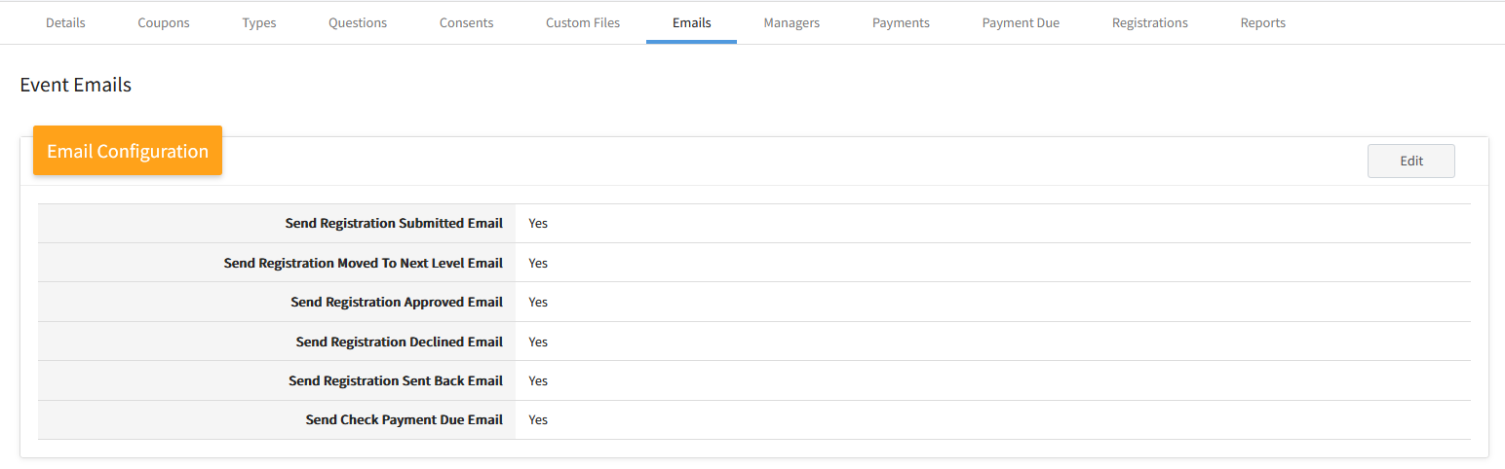
- Uncheck the System Emails that you do not want to go out for the event.  - Click Save to save your changes, or Cancel to exit the modal without making changes. | 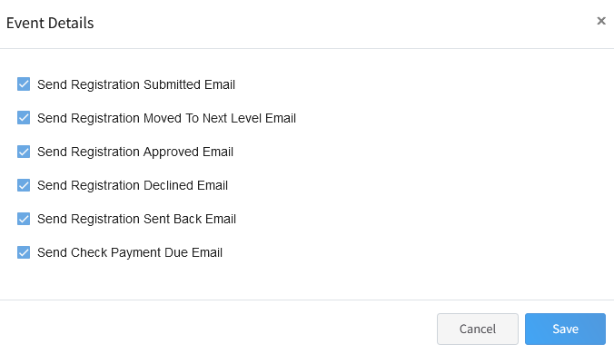
Setting up Custom Event E-mails
The event creator may set up customized event emails to be sent to individuals who have registered for the event when the registration hits a trigger point. In the absence of customized event emails, the default event email text for the program (set up by the System Manager) will be sent in their place.
- Click on the Emails tab.  - Click the + Add Email Template button | 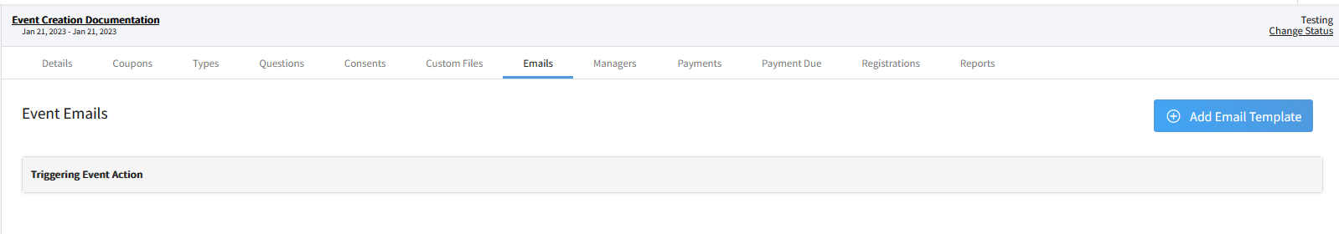
- Enter the Display Caption for the Email Template.  - From the drop-down menu, select the action that will trigger the email to be sent automatically to the registrant.  - Click the Add button.  - Repeat steps 2 – 5 for each email template you want to customize for the event. | 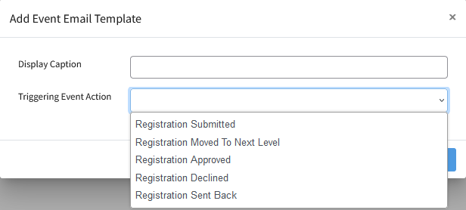

Event Managers
Before you start
            - Event Managers (Admin, Staff, and Volunteers) may only be associated with Manager Accounts.
            - For State Events, the event creator and the Primary Admin for the Institution level of the hierarchy will automatically be added as an Event Admin.
            - For County Events, the event creator, Primary Admin for the County creating the event and the Primary Admin for the Institution level of the hierarchy will automatically be added as an Event Admin.
            - All other event managers must be explicitly added to the event with permissions to manage the event.
            - Managers not added as Event Managers will be able to run shared reports or create their own event reports, but may only view information tied to the level of the hierarchy for which they have permissions.
Roles of Event Managers
- Event Admin – Full permissions to modify the event setup, Registration Management and Event Managers.
- Event Staff – Permissions for Event Setup, Registration Management, and Event Managers areas are set independently of each other.
- Event Volunteer – This is not a role for adult or youth volunteers in your program. Variable permissions for the Manager designated as an Event Volunteer.
Permissions
- Write Permissions – Gives the manager the ability to see and modify the information.
- Read Permissions – Gives the manager the ability to see the information, but not make changes they would not otherwise be able to make.
- None – Prevents the manager from seeing or modifing the event setup. Error notification of being unauthorized to view or updata data if selecting a tab in the event they do not have permissions to access.

Adding Event Managers
- Click on the Managers sub-tab in the event.  - Click the + Add Event Managers button. | 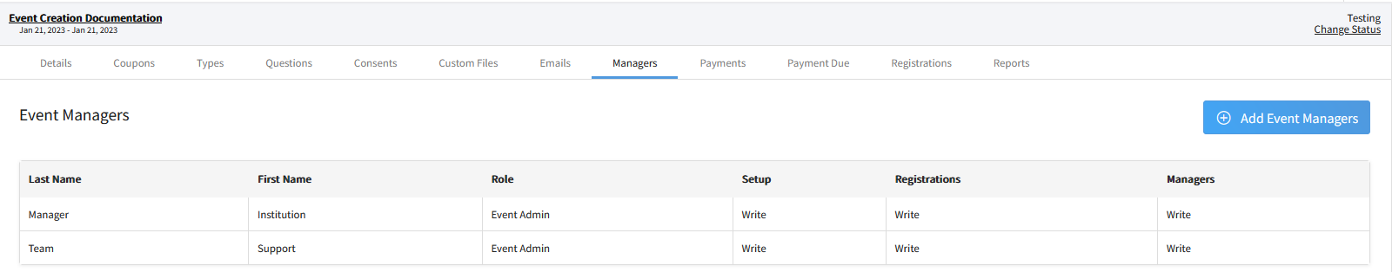
- Enter the Manager’s Name or Email Address  - Select the event Role of the Manager for the event (Admin, Staff, or Volunteer)  - Set the Event Setup permissions for the Manager (None, Read or Write)  - Set the Registration Management permissions for the Manager (None, Read, or Write)  - Set the Edit Event Managers permissions for the manager (None, Read, or Write)  - Click Save. | 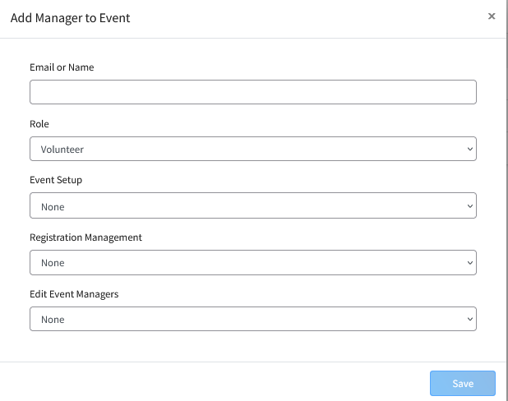

Setting the Event to Active Status
Before you start
Before you can begin to accept event registrations for the event, the event must be changed from Testing to Active Status. The event should remain in Active status until after the event is completed and all reports have been generated (unless you need to modify the event setup).
- Click Change status in the upper right corner of the screen. | 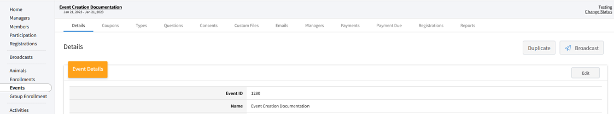
- Select Active in the pop-up window.  - Click Save.  - The system will automatically open the event to accept registrations according to the registration date set within each registration type. | 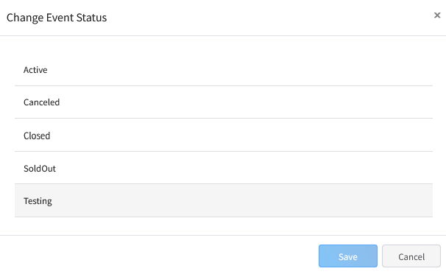
Tips
Do not make changes to custom questions or fees once you’ve started approving registrations.

Events that are open to the public (Participant role – anyone without an approved enrollment for the program year at the time of registration) do require that the program’s settings have enabled the Participant Role. Please check with your System Manager to confirm this role has been enabled for your program.

Events that will have fees collected do require that the program’s settings for Finances On is set to Yes. Please check with your System Manager to confirm this setting is enabled for your program.

