Instructional Tech Tip Sheet:
Accessible Word Documents

Overview
Making Word Documents accessible does not take a lot of work and is a “best practice” for following Michigan State University Accessibly guidelines. This tip sheet outlines some easy to follow suggestions for making your work accessible and includes links to step-by-step tutorials.

Formatting
- Bullets: When adding bullets use the pre-defined bullets in the paragraph editor of Word. Bullets will be read out loud to users of a screen reader.
- Color: Do not use color in text to convey a specific meaning.
- Font: Avoid formatting text with bold, italics or all caps. Screen readers may emphasize text in all caps as it is read.
- Font: Use at least a size 10 san serif type font (Examples: Arial, Helvetica, Tahoma, Verdana). These font types magnify well for those with low vision.
- Review Options: Comments and track changes are not accessible.

Headers
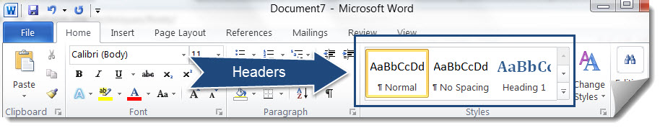
The Microsoft Word Headers found in the Styles area in Microsoft Word, as shown above, can be used to format sections within a Word Document and will be read by screen readers. You would not want to simply highlight text that you want to emphasize and manually Bold and Underline it.

Hyperlinks
Screen readers will read the text within a hyperlink so names of links should be meaningful. You should not use text such as “click here to be directed to the Michigan State University home page.” Instead use a format such as this where the descriptive text is hyperlinked and the URL is listed after the link with no hyperlink: Michigan State University (www.msu.edu). Listing the actual URL is optional.

Images
All images, photos, and charts should have alternative text associated with it. You can add alternative text to images in Word by right-clicking on the image, selecting Format Picture and Complete the Alt Text fields, as shown below.
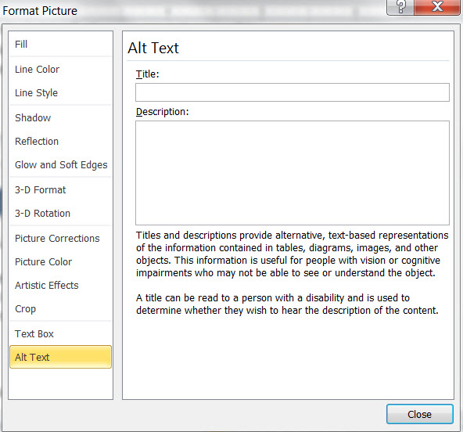

Accessibility Checker
Microsoft Word has a built-in Accessibility checker which will scan a document for any issues relating to accessibility. This is only available for .docx files. To access the checker select the File menu, Info, Check for Issues, and Check Accessibly. A window will appear on the right side of your document listing any issues.

Resources/Tutorials
- How to Make a Word Document Accessible, by Karen Sorenen, Portland Community College (expand titles on the web site by clicking on the plus icon for videos and more details): http://www.pcc.edu/resources/instructional-support/access/word.html
- How to Make MS Word documents Accessible: YouTube video by Karen Sorenen, Portland Community College (a six video series on making MS Word documents accessible)
- Michigan State University Web Accessibility Tutorials: http://webaccess.msu.edu/Tutorials/index.html
- Microsoft Word, by WebAIM: http://webaim.org/techniques/word/
- National Center on Disability and Access to Education Cheatsheets: http://ncdae.org/resources/cheatsheets/

