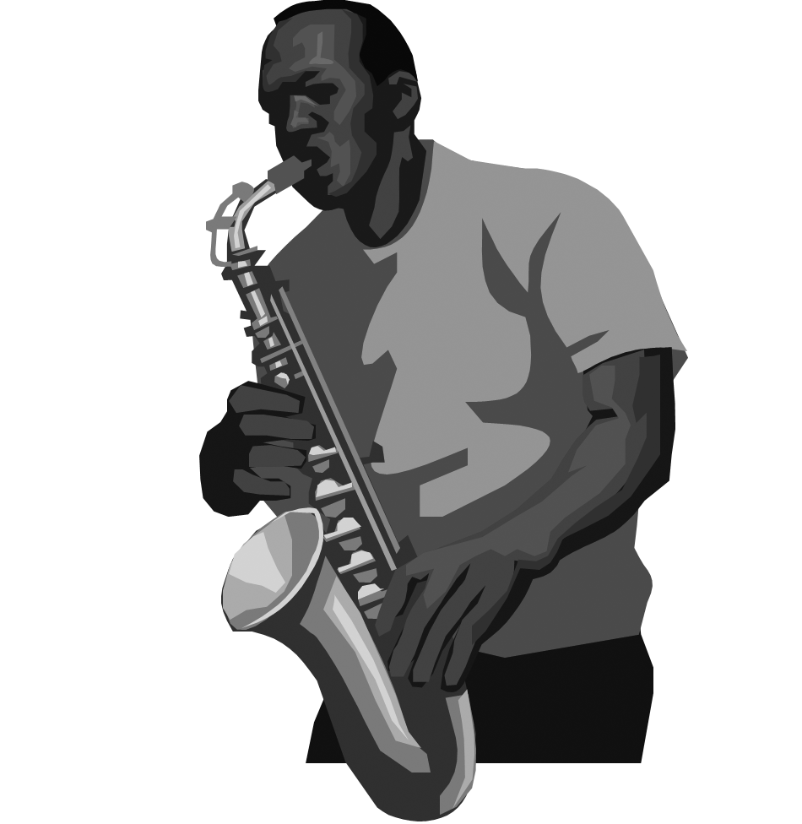
4-H Arts Project Evaluation Guidelines

For youth ages
9-19

4-H Arts Project Evaluation Guidelines for Youth Ages 9-19

Objectives for project evaluation with youth:
- Encourages self-assessment and reflection
- Affirms development of life skills
- Recognizes project accomplishments
- Guides in planning future activities
- Adjusts based on the youth’s age, experience and ability
- Makes positive youth development central to the evaluation process
Important reminders about arts project evaluation
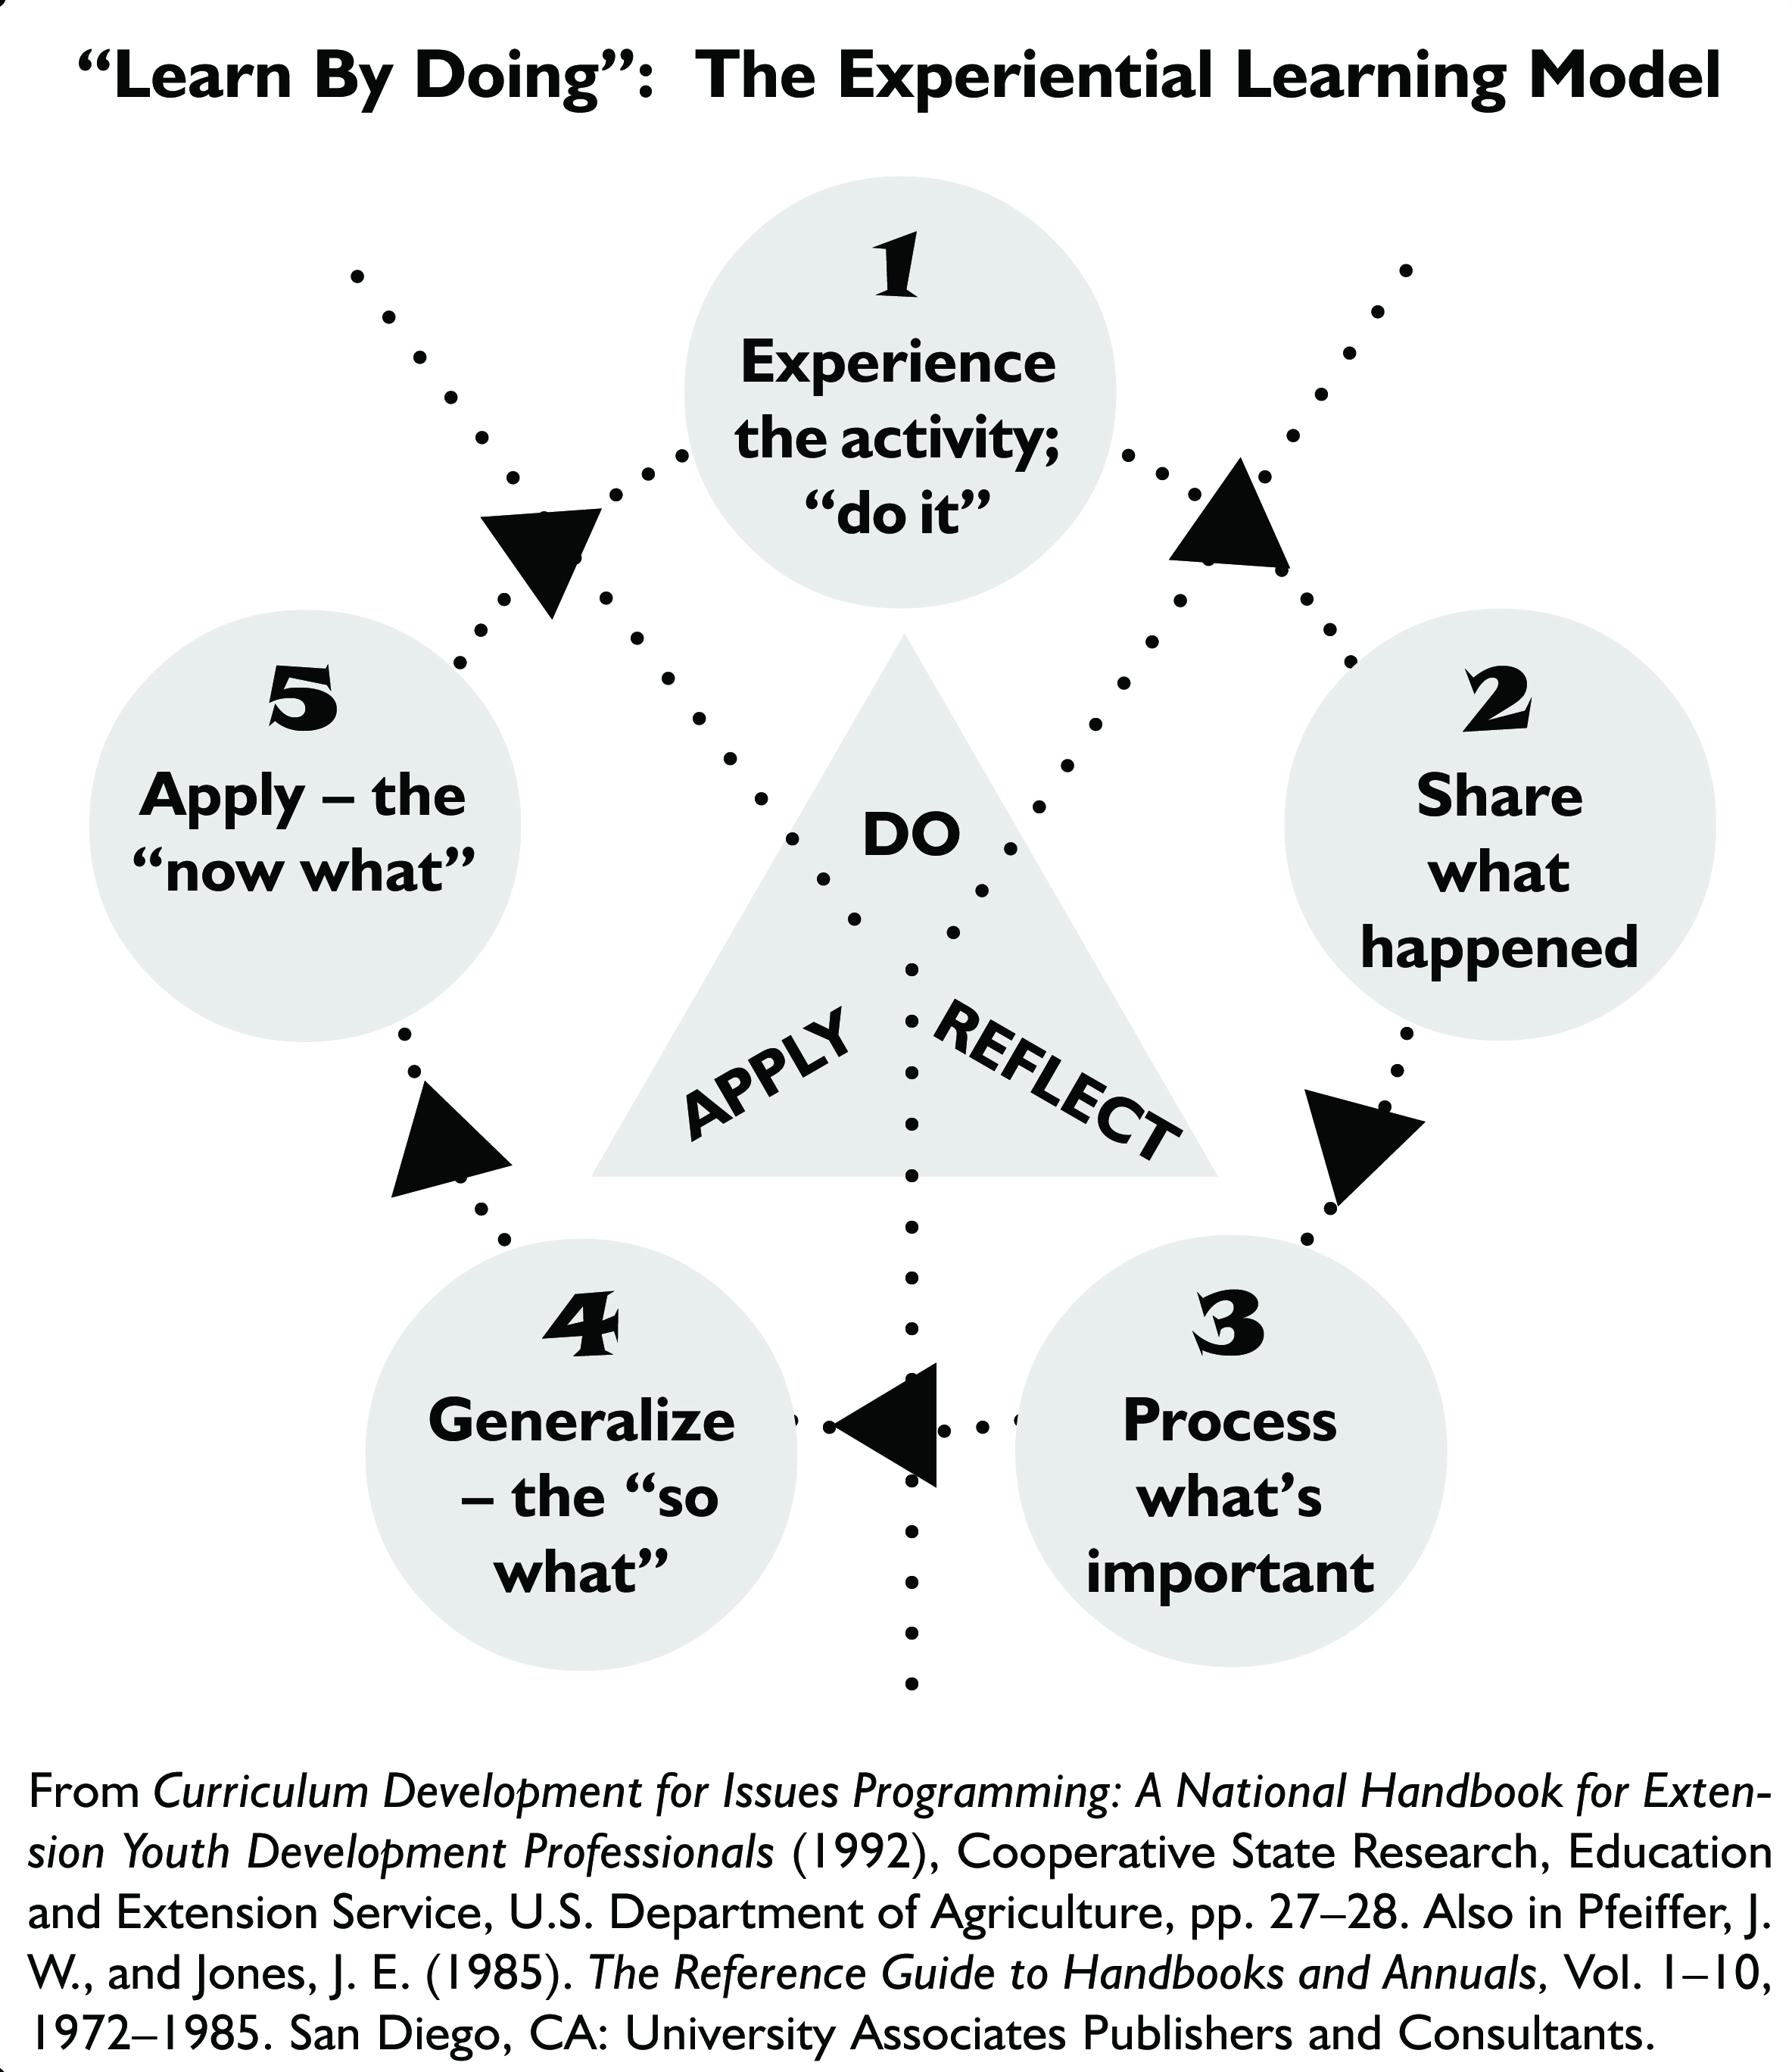
In general, it is ideal if a young person’s art is evaluated but not ranked or scored. The quality of art depends on more than doing the right thing technically; it also depends on the young person’s ability and confidence to express his or her ideas and feelings; make a statement; and experiment with the art medium. The very ‘heart of art’ is allowing self-expression and creativity to blossom. However, if you choose to assign points to the evaluation templates, consider assigning 30 points each to items one to three and 10 points to item four.

Instructions for using evaluation templates
The best evaluation scenario is when the youth sits down informally with the evaluator to talk about his or her art project. This potentially is an exciting and rewarding time for youth. It is also a rewarding time for the evaluator who has a unique opportunity to converse with a child about his or her art! This format holds true whether serving as an evaluator in a performing or visual art project, the difference being that a performing arts evaluator observes a performance first and then has a conversation with the youth.

The evaluation templates can be used as a conversation guide in the evaluation process. The templates can also be used to record important conversation points for the youth to use as he or she plans future arts activities. Encouraging self-assessment and reflection is the second component of the
4-H experiential learning process of “do, reflect and apply.” The third piece is the application of new awareness, knowledge and skills to future activities. An evaluator can richly reinforce the entire art project learning experience by being mindful of the experiential learning model.

The templates can be made project specific. For example, if you wish to develop an evaluation form for “felting” in visual arts, you could change the more generic descriptions under “Overall Artistic” to color(s) or combinations are pleasing, embellishment adds interest and under “Overall Technical” to firmly felted, evenly felted, pieces or parts firmly attached, fiber suitable for felting.

Evaluation comments, whether written or oral, must be constructive and given in a positive manner. An evaluation is a big deal in a young person’s life.

References
Evaluation and Recognition
Michigan 4-H Recognition Handbook. (2002). Michigan State University Extension (http://web1.msue.msu.edu/cyf/youth/downloads/recognitionhandbook.pdf)

”Signs of a Successful 4-H Club.” Michigan 4-H Club Development Guide. (2009). Michigan State University Extension (http://web1.msue.msu.edu/cyf/youth/downloads/4-HClubDevelopmentGuide.pdf)

Ages and Stages of Child and Youth Development
“The Ages and Stages of Child and Youth Development.” Michigan 4-H Club Development Guide. (2009). Michigan State University Extension. Pages C-2 to C-5. (http://web1.msue.msu.edu/cyf/youth/downloads/4-HClubDevelopmentGuide-AppendixC.pdf)

Design Elements and Principles
A Palette of Fun with Arts & Crafts: A Helper’s Guide for Children’s Art Activities Grades K-6.
4-H Cooperative Curriculum System. (2001). Pages 4-5.

Portfolio Pathways: Painting, Printing and Graphic Design, Youth Art Activities, Youth Art Activities with Helper Information. (2005). 4-H Cooperative Curriculum System. Pages 8-9.

Sketchbook Crossroads: Drawing, Fiber, Sculpture. (2005).
4-H Cooperative Curriculum System. Pages 8-9.

Photography
Focus on Photography: Project Book and Photo Journal,
Level 1. (2007) National 4-H Council. Page 66 - “You Be
the Judge.”



Evaluation Templates
(Your county and event name here)
4-H Visual Arts Project Evaluation (Individual)

Member Name ______________________________________________________

4-H Age/Date of Birth ____________________ Years in Project _________________

Project Category______________________________________________________

- Overall Artistic (use of design elements and principles, visually appealing)

- Overall Technical (skill in handling materials and tools; appropriate choice of materials, finishing)

- Originality and Imagination (creative way of using materials, own interpretation or ideas expressed)

- Project Presentation (appearance, finished layout as exhibited)

Comments

Evaluator’s Signature _________________________________ Date _____________

(Your county and event name here)
4-H Visual Arts Project Evaluation (Group)

Group/Club Name ______________________________________________________

Member Names and 4-H Ages/Dates of Birth _________________________________

_____________________________________________________________________

_____________________________________________________________________

Project Category________________________________________________________

- Overall Artistic (use of design elements and principles, visually appealing)

- Overall Technical (skill in handling materials and tools; appropriate choice of materials, finishing)

- Originality and imagination (creative way of using materials, own interpretation or ideas expressed)

- Project Presentation (appearance, finished layout as exhibited)

Comments

Evaluator’s Signature _________________________________ Date _____________

(Your county and event name here)
4-H Photography Project Evaluation

Member Name ______________________________________________________

4-H Age/Date of Birth ____________________ Years in Project _________________

Project Category______________________________________________________

- Overall Artistic (composition, strong focal point, use of design elements and principles)

- Overall Technical (photo quality including focus, good use of available lighting and proper exposure; correct camera resolution for image size printed)

- Originality and Imagination (tells a story, reflects a mood or feeling, unique perspective)

- Display Technique (enhances the photo, neat in appearance)

Comments

Evaluator’s Signature __________________________________Date _____________

(Your county and event name here)
4-H Performing Arts Project Evaluation (Individual)

Member Name ______________________________________________________

4-H Age/Date of Birth ____________________ Years in Project _________________

Project Category______________________________________________________

- Overall Artistic (expressive, unique and creative as medium allows)

- Overall Technical (skill, precision, execution)

- Category Specialty (comment as appropriate)
- Makeup
- Costuming
- Utilization of performance space
- Music appropriate (for dance, for youth’s voice range; for youth’s level of experience)

- Stage Presence & Showmanship (confidence, flow of act, audience appeal, interaction with audience)

Comments

Evaluator’s Signature ____________________________________ Date ___________

(Your county and event name here)
4-H Performing Arts Project Evaluation (Group)

Group/Club Name ______________________________________________________

Member Names and 4-H Ages/Dates of Birth _________________________________

_____________________________________________________________________

_____________________________________________________________________

Project Category________________________________________________________

- Overall Artistic (expressive, unique and creative as medium allows)

- Overall Technical (skill, precision, execution)

- Category Specialty (comment as appropriate)
- Makeup
- Costuming
- Utilization of stage space
- Music appropriate (to dance, for youth’s voice range, for youth level of experience)

- Stage Presence & Showmanship (confidence, flow of act, audience appeal, interaction with audience)

Comments

Evaluator’s Signature ___________________________________ Date ____________

(Your county and event name here)
4-H Writing Project Evaluation
Possible writing projects include: Poetry, Fiction, Personal Narrative (writing from personal experience) and Multi-Genre (a combination of poetry, fiction, personal narrative, journaling, scrapbooking and/or photography)

Member Name ______________________________________________________

4-H Age/Date of Birth ____________________ Years in Project _________________

Project Category______________________________________________________

- Overall Artistic (captures readers attention, creates a picture in reader’s mind, consistently engaging)

- Overall Technical (clarity, well-organized structure, work functions as a whole, sense of purpose, correct grammar and spelling with exceptions for artistic purposes; citations used when appropriate)

- Originality and Imagination (surprises reader, creative use of imagery, interesting use of language)

- Presentation (appearance, finished layout as exhibited)

Comments

Evaluator’s Signature ______________________________ Date _________________

