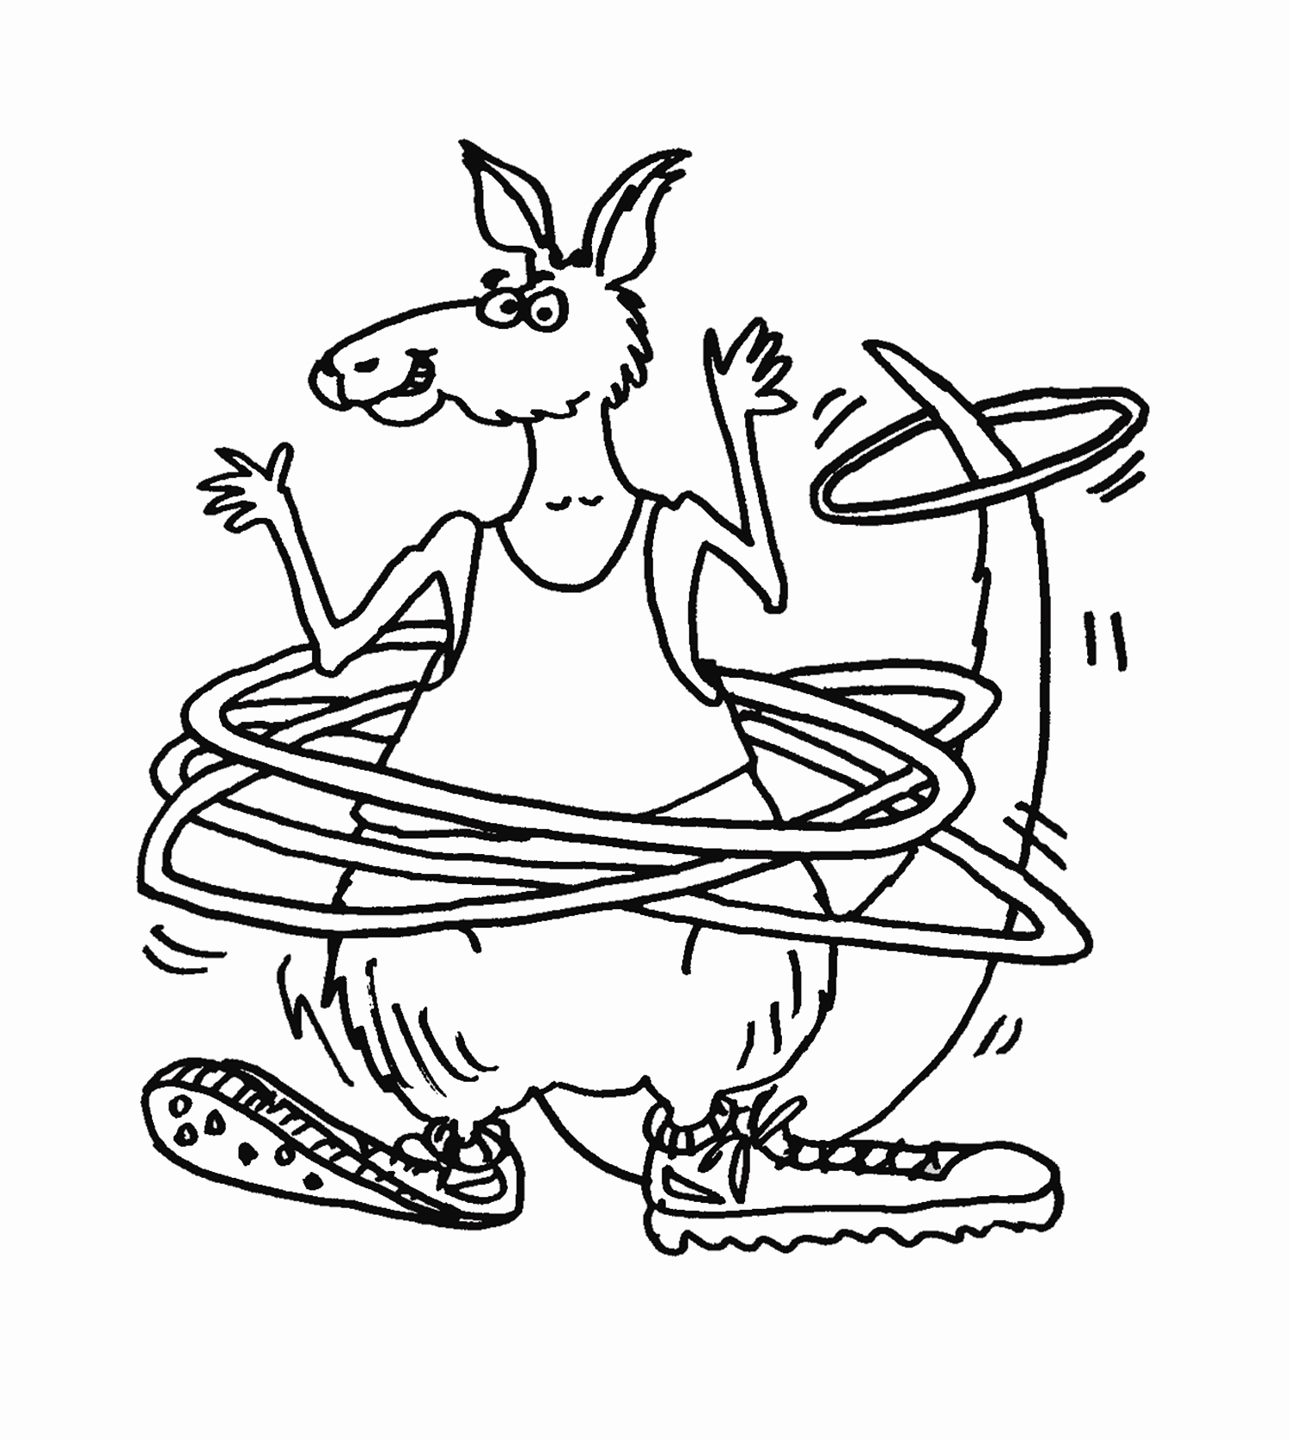
Jump Into Foods & Fitness
Training Agenda

Date:
Place:
Welcome to this Jump Into Foods and Fitness program training!
JIFF is about having fun with nutrition and fitness activities as a
way to encourage children to develop healthy lifestyles.
Agenda
9:00B9:30 a.m. Registration
9:30B10:00 a.m. Welcome
Overview of JIFF Kangaroo Jumps (JIFF Power Point Presentation)
Working With Groups and Experiential Learning Process

10:00B10:30 a.m. MyPyramid and Nutrition Background Basics
JIFF Nutrition and Food Safety Activities

10:30B11 a.m. Physical Fitness Background Basics
JIFF Fitness Activities and Adaptations
(Warm-Up, Strength/Flexibility/ Endurance, Cool Down)
11:00B11:15 a.m. Break and Healthy Snack Recipe
11:15-12:00p.m. Your Turn With JIFF! (Have small groups prepare and share a nutrition, fitness or food safety activity with the whole group.)

Noon-1:00 p.m. Lunch With Physical Activity Snack
1:00-1:30 p.m. JIFF Sound Off Survey and Enrollment

1:30-2:00 p.m. Sharing Session (Groups discuss how they can implement JIFF in their work with youth.)

2:00-2:30 p.m. Q & A / Training Feedback

Enjoy sharing the message about enjoying nutritious food and active lifestyles with kids and families. We hope you and the children in your programs have fun with Jiff the Joey, foods and fitness, too! Thank you for attending!

