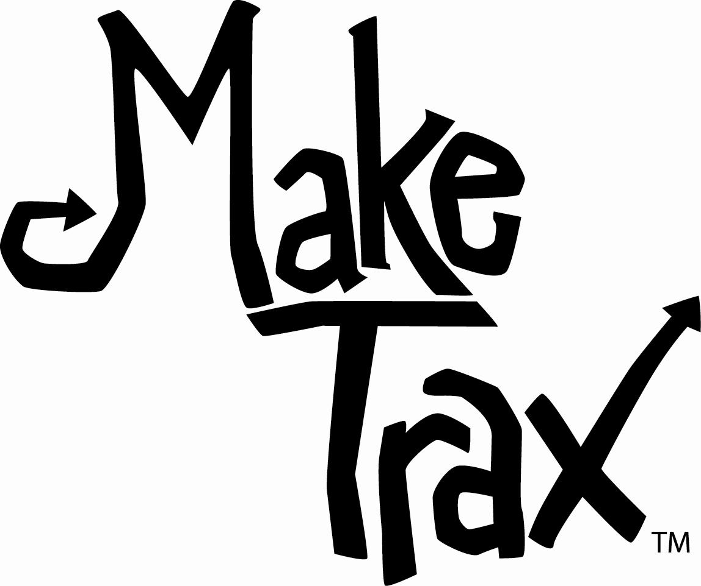

Make Trax Recommendation Worksheet

Recommendation | Other Partners
Education
1.
2.
3.
Encouragement
1.
2.
3.
Route
1.
2.
3.
Make Trax Recommendation Worksheet Page 1 of 1
© Michigan Fitness Foundation and Michigan Department of Transportation, 2010

